**Definition**

**IaaS: Provision servers, storage and networking resources.** Infrastructure provider makes an entire computing infrastructure available as service. IP manage a large pool of computing resources and use virtualization to assign and dynamically resize the resources required by the customers. E.g. **Amazon EC2, S3, Azure Storage**

**PaaS: The middleware platform and solution stack are accessible on the cloud.** Service provider supplies the software platform or middleware where the applications run. E.g. **Facebook**, **Google app Engine**

**SaaS: Use of software or applications that are delivered via a network.** SP is responsible for the creation, updating and maintenance of software and application. Service user accesses the service through Internet-based interfaces. E.g. **Google’s Drive, iCloud, Dropbox.**

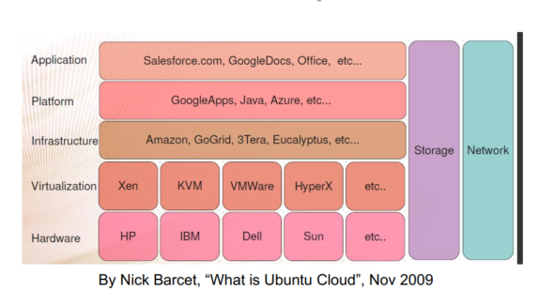

**Serverless: Allow a cloud user to simply write the code and leaves all the server provisioning and administration tasks to the cloud provider.**

**Serverless Computing = FaaS + BaaS** E.g. Amazon Lambda, Google Cloud Azure Functions. **FaaS (Function-as-a-Service): cloud functions**

**BaaS (Backend-as-a-Service): Serverless frameworks**

**Cloud Deployment Models**

**Public Cloud:** Service provider lets clients access the cloud via the Internet. Made available to the general public or a wide industry group.

1.Multitenant infrastructure 2. Anyone may use. 3. Functions vary

4. Fee arrangements vary.

**Private Cloud:** The cloud infrastructure is used solely by the organization that owns it. May reside in-hourse or off premises.

1.Secure, dedicated infrastructure 2. User buys or leases the cloud

3.Not burdened by network bandwidth, availability or security exposures.

Offer the provider and user greater control, security and resilience.

**Hybrid Cloud:** Composed of two more clouds (private, public or community) that remain in unique entities, but can interoperate using standard or proprietary protocols. 1.Allow applications and data to flow across clouds. 2.Requires interoperability, visibility and management.

3.Support a very flexible performance model.

**Community Cloud:** Shared by several organizations that have a common mission. 1.Used and controlled by a group of organizations with shared Interest. 2.Private cloud purchased by a single user to support a community of users. 3. Frees may be charged to subsidiaries.

**Virtual Private Cloud:** A VPC is dedicated to a single user within a public cloud. Extends the customer network into the cloud providers’ space, by making additional resources available on demand.

**Security Risks**

**Virtualization and Multitenancy** technologies were not designed with strong isolation. Side channel attacks: VMs infer behaviors of other VMs.

**Nonstandard and vulnerable APIs:** Cloud API are not standardized, forcing users of multiple cloud providers to maintain multiple programming interfaces, increasing complexity and security risks. A weak API exposes customers to a variety of security issues.

**Internal Security Breaches:** Over 70% of security violation are internal.

**Data Corruption or Loss:** These operational characteristics of the cloud environment, at the PaaS and SaaS layers, amplify the threat of data loss or leakage increase. **User Account and Service Hijacking:** If attackers gain access to a cloud user’s credentials, the can eavesdrop on activities and transactions, manipulate or steal data, return falsified data, and redirect clients to illegitimate sites.

**Hadoop and MapReduce**

**Hadoop:** Hadoop is a reliable shared storage and analysis system. The storage is provided by Hadoop Distributed File System (HDFS) and analysis by MapReduce. (Pig, Hive, HBase, ZooKeeper)

MapReduce is a programming model that gives: 1.Automatic parallelization and distribution 2. Fault-tolerance 3. I/O scheduling

4. Status and monitoring

**Examples**: Count of URL access frequency. Reverse Web-Link Graph.

Inverted Index. Distributed Sort.

**MapReduce data flow in Hadoop:**

* Two types of datanodes: 1. Master: coordinate all jobs 2. Worker/slave: runs tasks and sends report to master.
* Hadoop divides the input into a fixed-size pieces called splits. Hadoop create one map tasks for each split and map function runs each record.
* Split size: Too large then the program may stuck at one split, lack of parallelization. If too small, increases management overhead. A good split size = HDFS block (default 128 MB)

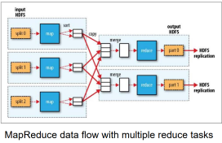**Data locality optimization**: Hasoop tries to run the map task on a node where the input data resides in HDFS, Map tasks write their output to the local disk. Reduce tasks don’t have the advantage of data locality. The input of reduce tasks is the output from all mappers.

**Fault tolerance**: If the map tasks fails before the map output has been consumed, Hadoop will rerun the map task on another node. The output of reduce is normally stored in the HDFS for reliability. For each HDFS bl0ock of the reduce output, the first replica is stored in local node, with other replicas being stored on off-rack nodes.

**Partition:** Map outputs are partitioned to multiple reduce tasks. Often a simple hash key “H(k) mod R

**Combiner:** Map outputs are reduced (or combined) before being sent to reducers. Used as an optimization to reduce network traffic.

**HDFS**

Data is stored in multiple disks in a number of separate machines. Designed for storing very large files with streaming data access patterns, running on clusters of commodity hardware. 1. Very large files

2.Streaming data access: write-once, read-many-times patterns.

3. Commodity hardware: low-cost hardware is used. Hardware failure is a norm rather than exception.

**Simple coherency model:** data wont be changed. Simplifies synchronization overhead.

**Moving computation is cheaper than moving data:** migrate the computation closer to where the data is located rather than moving data to where the application is running.

Application are not suitable for HDFS: 1. Requires low-latency data access 2.Lots of small files. 3.Multiple writers, arbitrary file modifications.

**Architecture Overview of HDFS:** HDFS has a master/slave architecture. A single namenode, that manages the file system namespace and regulates access to files by clients. Multiple datanodes, manages storage attached to the nodes, and serves read/write data requests from clients.

**Data Blocks:** HDFS arranges data in blocks of large size to minimize the cost of disk seeks. Also the metadata file will be smaller, reducing the metadata overhead. The drawback of large block is lack parallelization.

**HDFS namespace:** supports a traditional hierarchical file organization, create, remove files, move file from one dir to another and rename a file.

Doesn’t support user quotas, access permissions, hard/soft links. The filesystem namespace is maintained at the namenode.

**Data Replication:** for fault tolerance, block size and replication factor are configurable per file. The namenode makes all decisions regarding replication of blocks. It periodically receives a heartbeat and a blockreport from each of the datanodes. Heartbeat: keep-alive message

Blockreport: a list of all blocks. Default replication factor = 3.

Rack-aware placement – balance reliability and write performance.

One replica in one node in the local rack. One replica in another node in the local rack. One replica in a different node in a different rack. HDFS tries to satisfy a read request from a replica that is closest to the reader. (decided by the namenode)

**Communication Protocols:** All HDFS communication protocols are layered on top of the TCP/IP protocol. A Remote Procedure Call abstraction wraps the communication protocols. Namenode never initiates any RPCs. It only responds to RPC requests issued by Datanodes and clients. **Data disk failures:** namenode receives no heartbeats -> datanode fails -> re-replicate data to new datanodes.

**Cluster rebalancing:** HDFS can dynamically generate new replicas and rebalance other data to the cluster. **Data Integrity:** Checksum is attached to each block to check corrupted or not. **Namenode Failure:** it’s a single point failure of HDFS. Need manual intervention.

**HDFS read：**1. HDFS client opens the file through FS object. 2. The FS object calls the namenode, using RPC, to determine the location of the blocks for first few blocks in the file. FS Object returns an input stream.

3. The client call the read function to retrieve data blocks through the input stream. 4. Data is streamed from the datanode back to the client, which calls the read function repeatedly on the input stream. 5. When the EOB is reached, the input stream will close connection to datanode and find the best datanode for the next block. 6. When finished reading, close the input stream. If the input stream encounters error , it will try the next “closest” one for that block. **Distance = 0** (processes on the same node) **Distance = 2** (diff. nodes on the same rack) **Distance = 4** (nodes on diff. racks in the same data center) **Distance = 6** (nodes in diff. data centers)

**Node -> top of rack switch → high level switch connecting diff. racks → high level switch connecting diff. data centers → high level switch of another data center → top of rack switch → diff node.**

**HDFS Write:** 1. HDFS client create the file on the FS object. 2. The FS object makes an RPC call toe namenode and create a new file in FS’s namespace. Output stream is created. 3. As the client writes data, the output stream splits it into packets, and writes to an internal queue called the data queue. 4. The output stream streams the packets to the first datanode in the pipeline, which stores the packet and forwards it to second datanode, followed by the third (and last) datanode. 5. The output stream maintains the internal queue of packets that are waiting to be acknowledged by datanodes called the ack queue. A packet is removed from the ack queue when it has been acknowledged by all the datanodes. 6. When client finished writing data, close output stream.

7. The client contacts the namenode to signal that file is completed.

Pipeline approach use up all the network bandwidth, receiving and sending data simultaneously. The drawback of pipeline approach is that when the client doesn’t receive the acknowledgement, client doesn’t know where the problem occurred. Dispatch approach will send data with 1/n times of the width to n datanodes.

**YARN (Yet Another Resource Negotiator)**

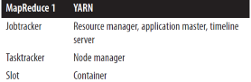

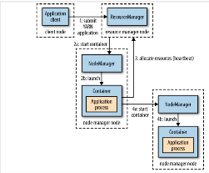1.The client requests the resource manager frunning an application master process. 2. The resource manager finds a node manager to launch the application master in a container. 3. The application master may request more resources if necessary. 4. The application master runs the requests in containers.

**YARN Resource Management**

Request based scheduling

**Containers**: leases on CPU and memory resources

1.Locality constraints can be used to request a container on specific nodes or racks. 2.Application can request resources upfront or dynamically

**Timeline Server:** keeps track of job history.

**Past Paper Questions:**

**Vendor lock-in**:difficult to switch to another cloud provider. Becoz

API are different, already have a lot of data on previous cloud, difficult

to transfer data to new provider. **Solution**: split and store subset of data

in different clouds. If one cloud is shut down, the amount of data to move

is lesser. / Standardized APIs.

**Multitenancy:** Simple multitenancy – all resources are shared, but the customer data and access are segregated from others. (relatively inefficient).

Fine grain multitenancy – all resources are shared but the customer data and access capabilities are segregated within the application. Problem: Security issue because of weak isolation. Creating an environment where attackers can gain access at the operating system level and higher-level services (functionality and data).

**MapReduce Programming**

**Client:** submits the MapReduce job.

**YARN resource manager:** coordinates allocation of cluster resources.

**YARN node managers:** which launch and monitor compute containers.

**MapReduce application master** coordinates the tasks of MapReduce job

**Distributed filesystem:** stores and shares job files between other entities

**Job Completion**: A job is complete if the application master receives a notification that the last task for a job is complete. The application master will send an HTTP job notification to client, clean up its working state and notify task containers to clean up the states. **Task failure:** if a task is crashed or hanging, it fails. The application master reschedules the task on a diff. node manager. If any task fails 4 times (default), whole job fails.

**Application master failure:** The resource manager detects the failure and starts a new master instance in a new container and tries to recover the state of tasks using job history. **Node manager failure:** The resource manager recovers task/application master failures as above and removes the failed node manager. **Resource manager failure:** Single point of failure, need active and standby resource managers.

**Shuffle and Sort**: shuffle is the process by which the system performs the sort in map and transfers the map outputs to reduces as inputs, and it’s done on both map and reduce sides.

**Task Execution – Optimization:**

* **Speculative Execution:** Job execution time is bottlenecked by the slowest running task. If a task running slow, Hadoop launches another, equivalent task as a backup. When the task finishes, any duplicated tasks are killed.
* **Skipping bad records:** Bad records throw runtime exceptions, causing a task to retry or even halt (after 4 retries). If skipping mode is enabled, failed records are skipped after the task is retried twice.

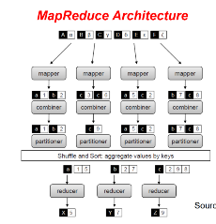**MapReduce Algorithm Design**

**Map (k1, v1) → list(k2, v2):** Takes an input key/value pair, produces a set of intermediate key/value pairs. **Reduce (k2, list(v2)) → list(k3, v3):** Takes a set of values for an intermediate key, produce a set of output values, the MapReduce guarantees that all values associated with the same key are brought together in the same reducer. Par

**Fundamental principle:** No inherent bottlenecks as algorithms are applied to increasingly large datasets. **Linear scalability:** an algorithm running on twice the amount of data should take only twice as long, running on twice the number of nodes should only take half as long.

**Local aggregation:** reduce the number of key-value pairs that need to be shuffled from the mappers to the reducers. **Default combiner:** provided by MapReduce framework, aggregate map outputs with the same key, acts like a mini reducer. Without combining, there will be I/O overhead, reading and writing too many key and value pairs, reduce heavy network traffic.

**In-mapper combining:** Emitsa key-valuepair for each unique term per document Mean Case

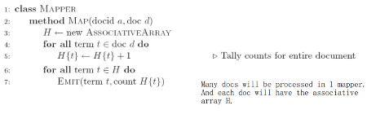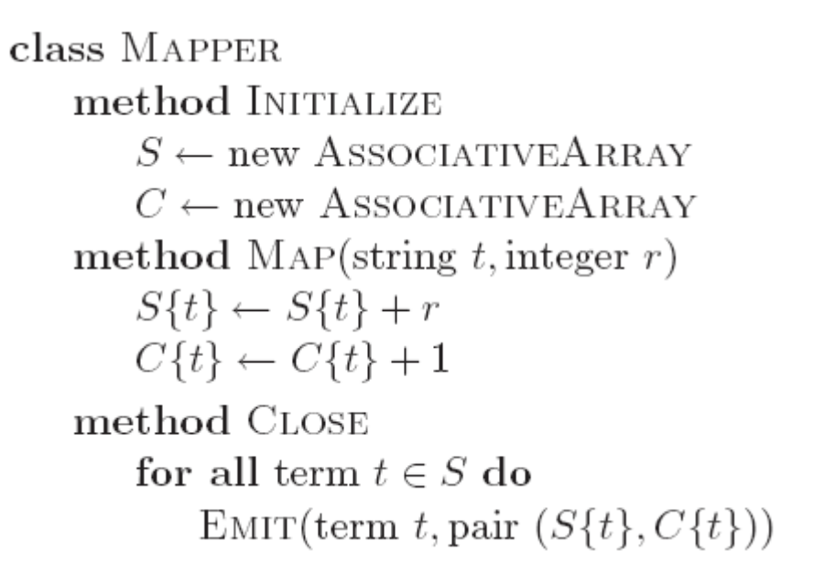 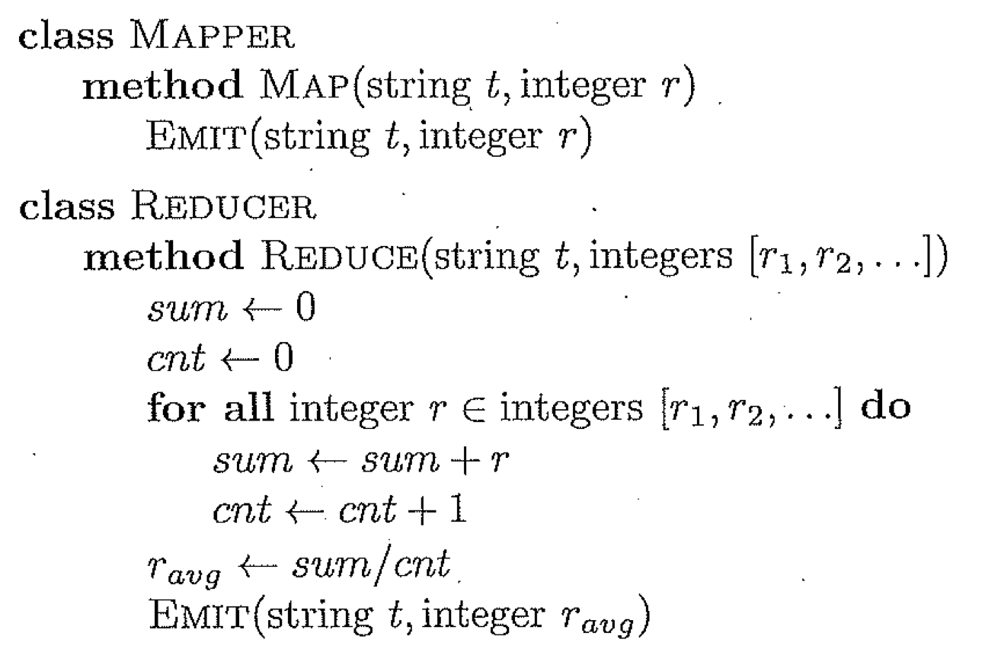

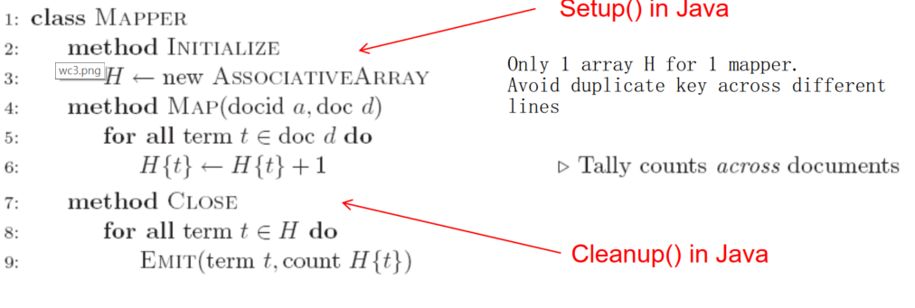

**Advantages of in-mapper combiners:** 1. Provide controlover where and how local aggregation takes place. In contrast, semantics of default combiners are underspecified in MapReduce. 2. In-mapper combiners are applied inside the code. Default combiners are applied to the map outputs. **Disadvantages:** 1. States are preserved within mappers →potentially large memory overhead. 2. Potential order-dependent bugs.  
**Combiner Design:** combiner and reducer must share the same signature, is treated as mini-reducer. Combiner input and output key-value types must match the reducer input key-value type.

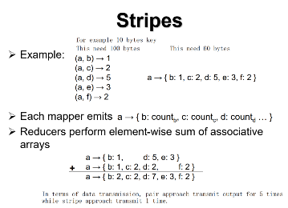**Pairs:** Each mapper emits intermediate key-value pairs with each co-occuring word pair and integer 1. Each reducer sums up all values associated with the same co-occuring word pair.

**Stripes:** Each mapper stores co-occurrence information in an associative array for each particular word. Emits intermediate key-value pairs with words as keys and corresponding associate array as value. Each reducer sums all the counts in the associative array.

**Pairs:** Pro Easy to understand and implement. Con generate too many key-value pairs. **Stripes: Pro** Generate fewer key-value pairs. Pro make better use of combiners. Con: Memory size of associative array in mappers could be huge.

**RF problem:** If we don’t have enough memory for stripe approach, we will need to use pair approach with order inversion. But make sure the marginal count comes before individual counts.

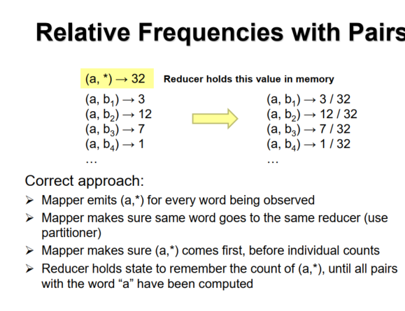 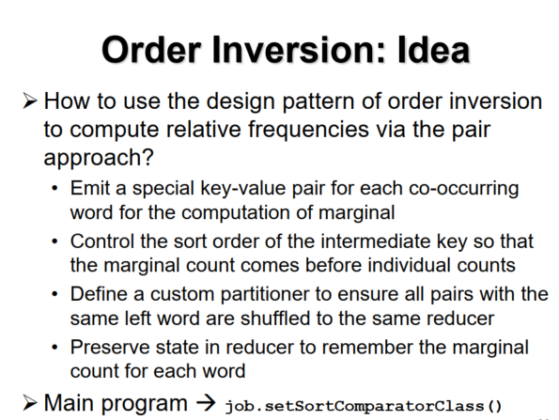

**Issue and Tradeoffs:**

* Number of key-value pairs →Object creation overhead. Time for sorting and shuffling pairs across the network.
* Size of each key-value →De/serialization overhead
* Local aggregation →Opportunity to perform local aggregation varies. Combiners make a big difference. Combiners vs. in-mapper combining. RAM vs. disk vs. network.

Secondary Sorting

MapReduce sorts input to reducers by key. Values may be arbitrarily ordered. What if want to sort value also? Sensors record temperature over time. Each sensor emits (id, time t, temperature v).

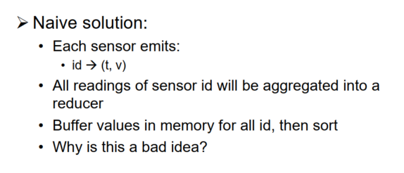 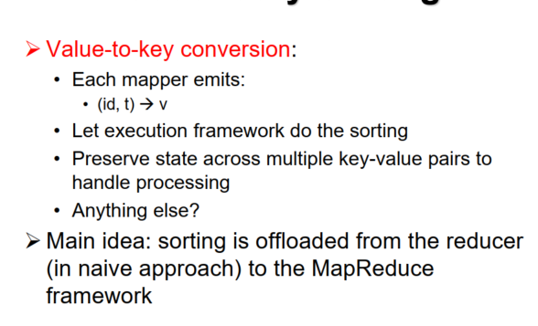

**Applications (lec 5)**

**Inverted Index:** a data structure that given a term provides access to the list of documents that contain the term. Used by most full-text search engines today. Retrieval engine uses the inverted index to score documents that contain the query terms based on some ranking model.

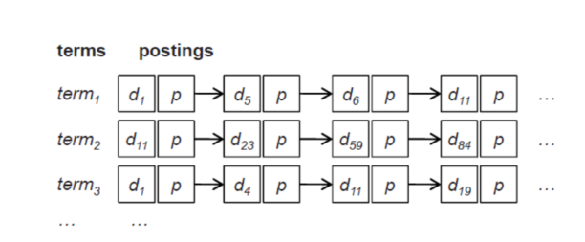

**Posing:** a tuple of (doc id, payload) associated with a term. Doc Id – Assumed to be unique integer from 1 to n where n is the total num. of docs. Payload – Could be empty for simple bool retrieval. Could include term frequency. Given a query, retrieval involves fetching posting lists associated with query terms and traversing the postings to compute the result set.

**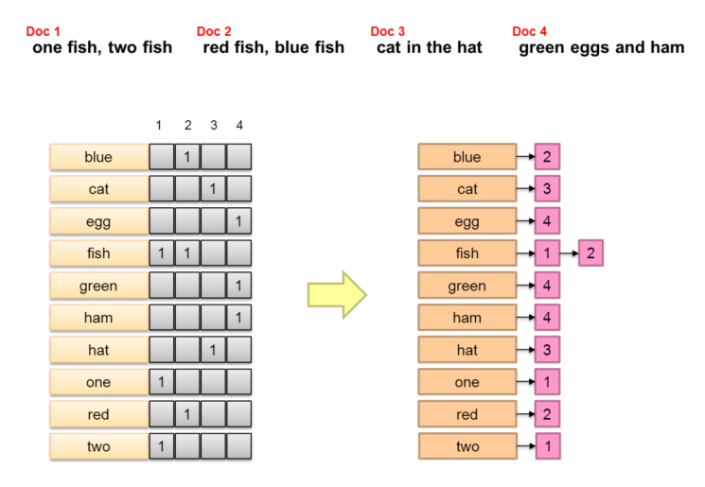

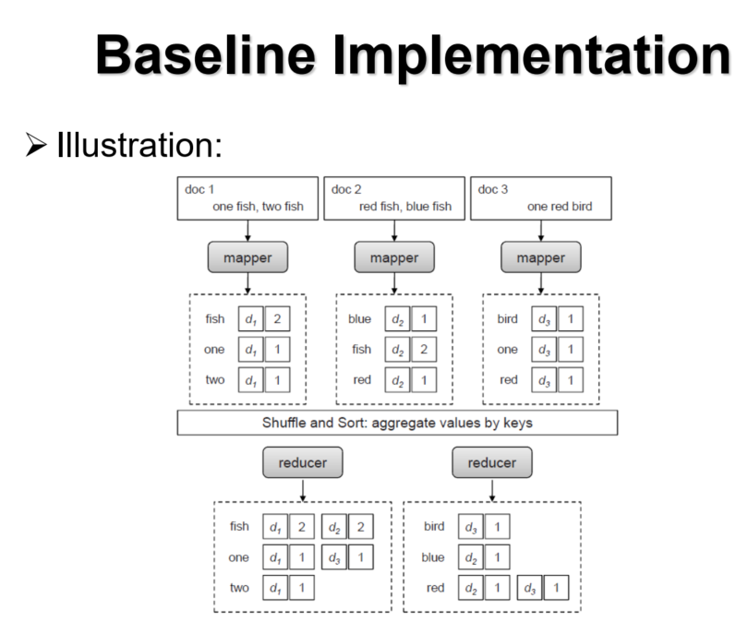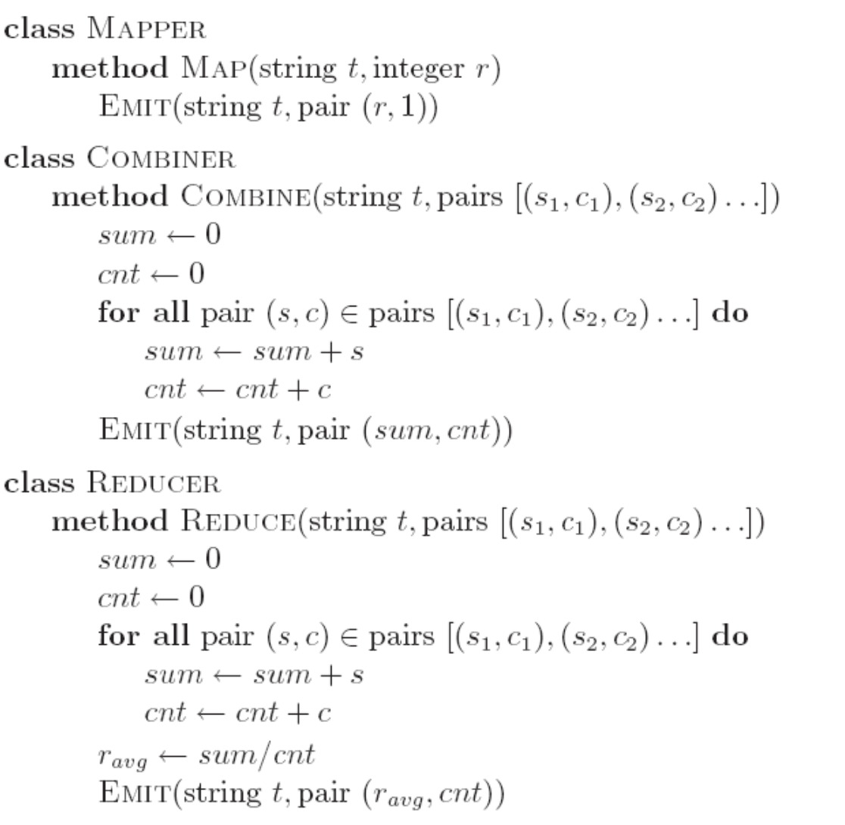

**PAIR AND STRIPES**

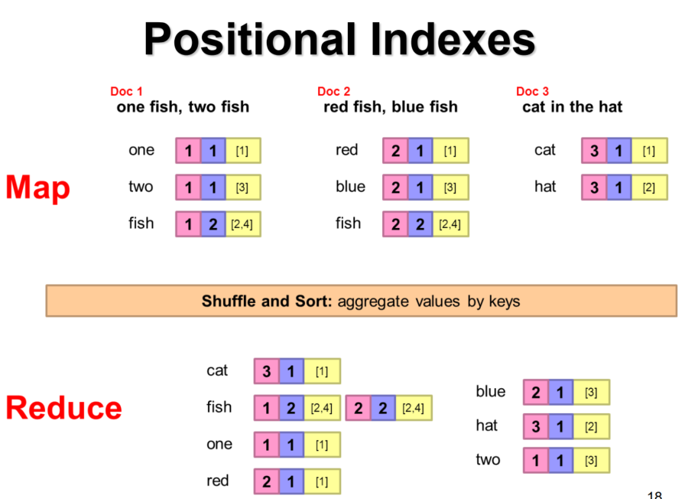 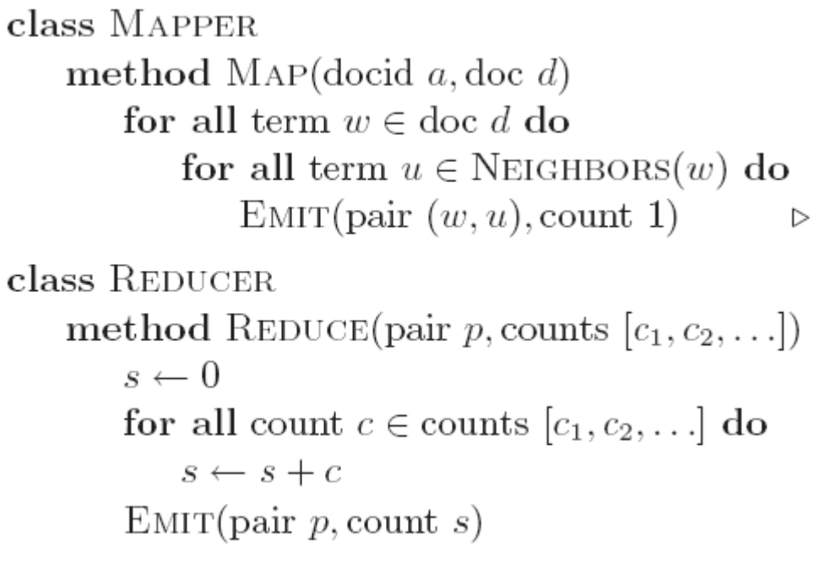

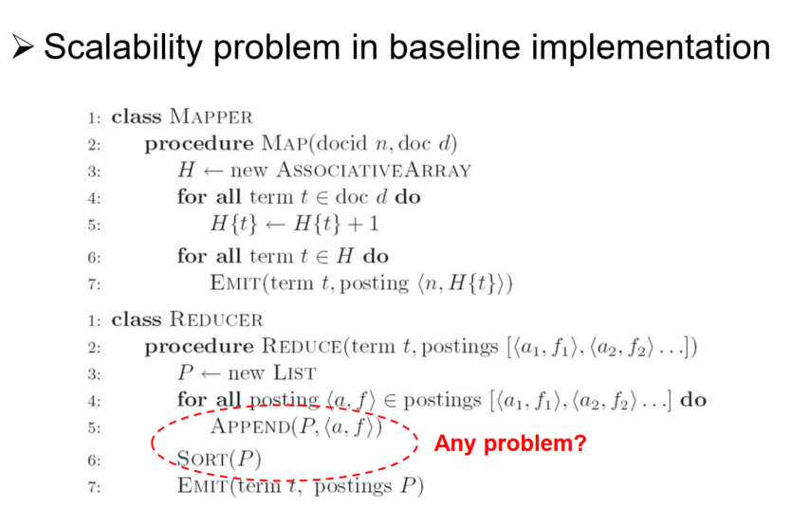 **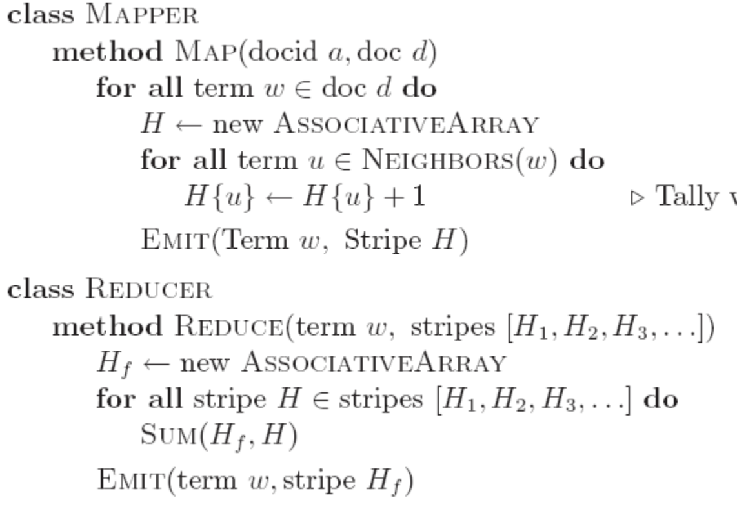  
Order inversion --> job.setSortComparatorClass()**

**Scalability Issue:** Assumption of the baseline implementation is that reducer has sufficient memory to hold all postings associated with the same term. The MapReduce framework makes no guarantees about the ordering of values associated with the same key. The reducer first buffers all postings and then performs an in-memory sort before writing to disk.

Instead of emitting (term t, positing <docid, f>), emit (tuple<t, docid>, f) by Value-to-key conversion. With value-to-key conversion, the MapReduce framework ensures the postings arrive in sorted order. Caution – you need a customized partitioner to ensure that all tuples with the same term are shuffled to same reducer.

**Retrieval –** MapReduce is designed for large batch operations and is a poor solution for retrieval. Use distributed retrieval and partition indexes across multiple servers. Document partitioning is generally faster – parallelize the search of a query term over multiple servers, each handling a subset of documents. Term partitioning – aggregates the search of a query term in one single server. Popular terms may create “hot spots” on servers. But it generally involves fewer disks seeks since the results are aggregated for each term.

**Graph Algorithms**

**Graph representation:** **Adjacency matrix** is easy to manipulate with linear algebra, easy for algorithmic implementation. But it requires large memory space, especially for sparse graphs, the matrix will contain many zeros. **Adjacency List** is much more compact representation, easy to compute over out-links. But it is much more difficult to compute over in -links. Because you will need to search all other nodes O ( $n^{2})$ for worst.

However, the shuffle and sort mechanism in MapReduce provides an easy way to group edges by destination nodes, thus allowing us to computer over incoming edges in reducer.

**Parallel Dijkstra’s Algorithm / Parallel BFS**

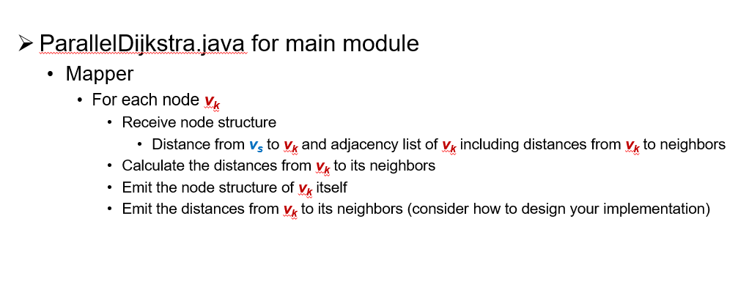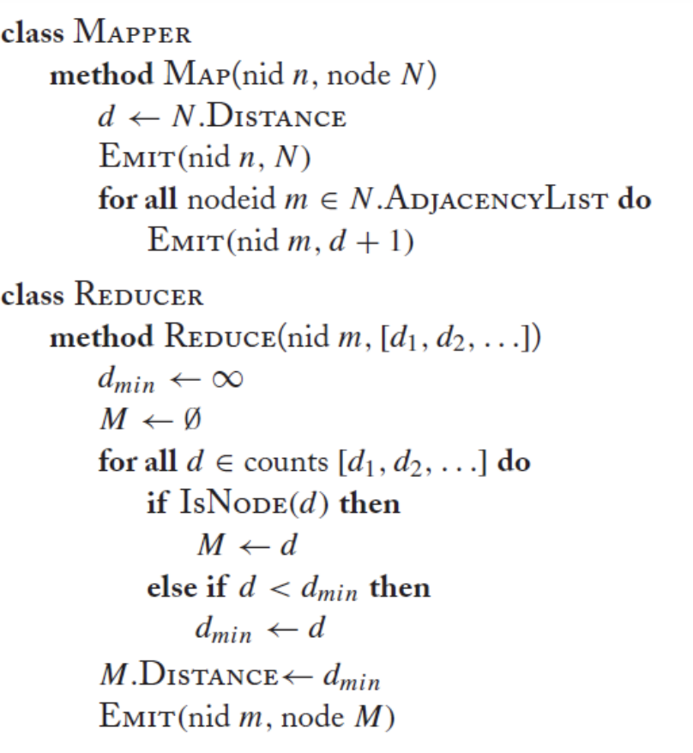

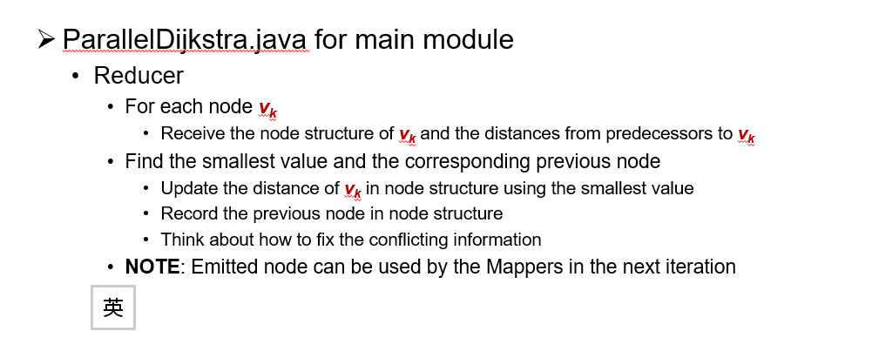

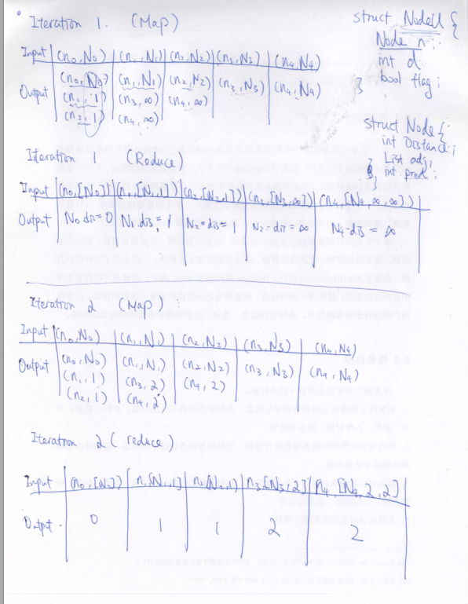

**Stopping Criterion:** Until all nodes are processed or input iterations.

**PageRank Algorithm: A measure of web page quality, used by Google’s search algorithm, it characterizes the amount of time spent on any given page, or how frequently a page is encountered by a random surfer. Mathematically, it is a probability distribution over pages.**

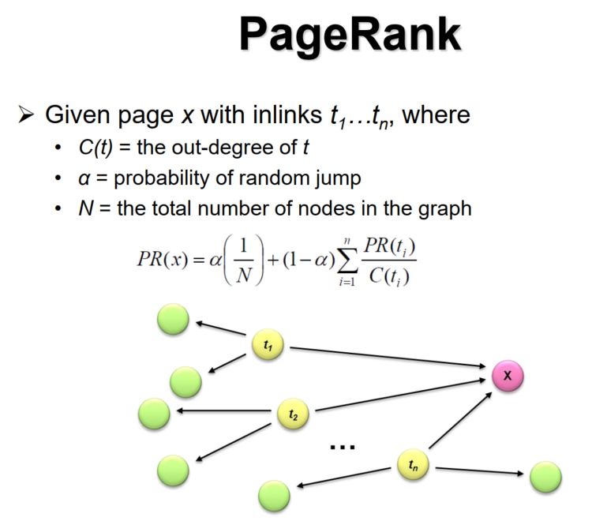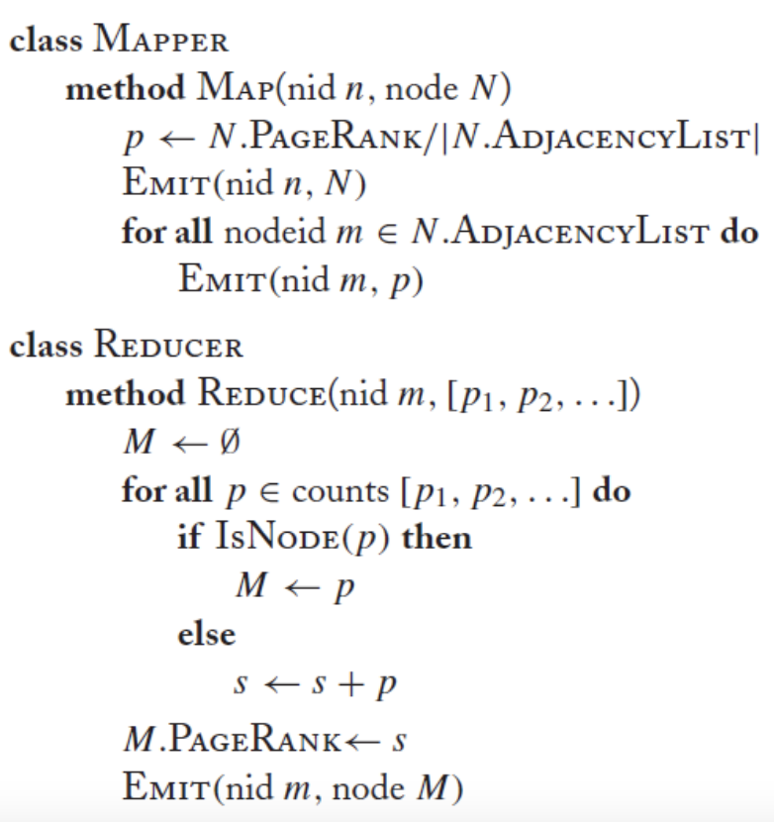

**Spider trap:** generate an infinite chain of pages that all link to a single page, so as to inflate the PageRank value. Assume a community of honest users.

**Properties of PageRank:** Can be computed iteratively.

Sketch of algorithm: Start with seed ${PR}_{i}$ values (e.g., every page has equal PageRank). Each page distributes ${PR}_{i}$ credit evenly to all pages it links to. Each target page adds up credit from multiple in-bound links to compute ${PR}_{i+1}$. Iterate until values converge.

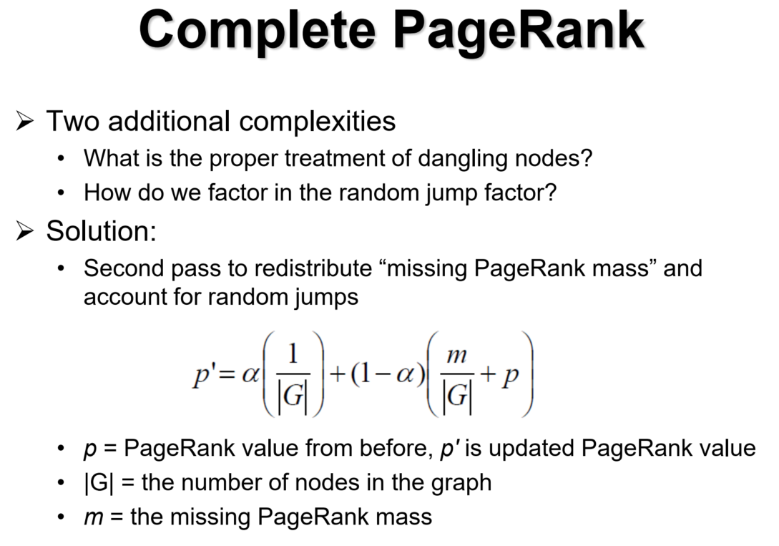

Write:

• Updates committed to a commit log

• Recently committed updates are stored in memtable

• Older updates are stored in a sequence of SSTables  
Read: (load imbalance due to the load is dynamic, the load is different after every rebalance) Additional data movement, create overhead)

• form a merged view of SSTables and memtable

• read <key-value> pair **B+ tree-->find the location of the SSTable/HFile**

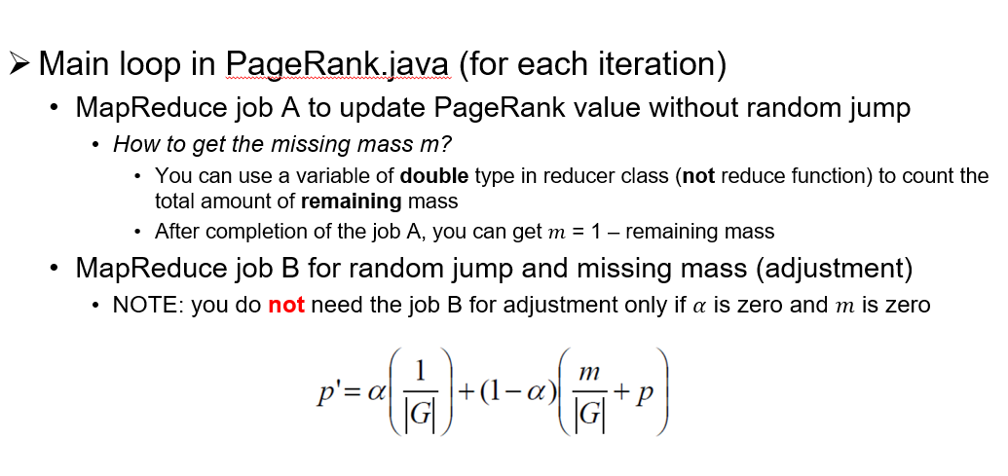

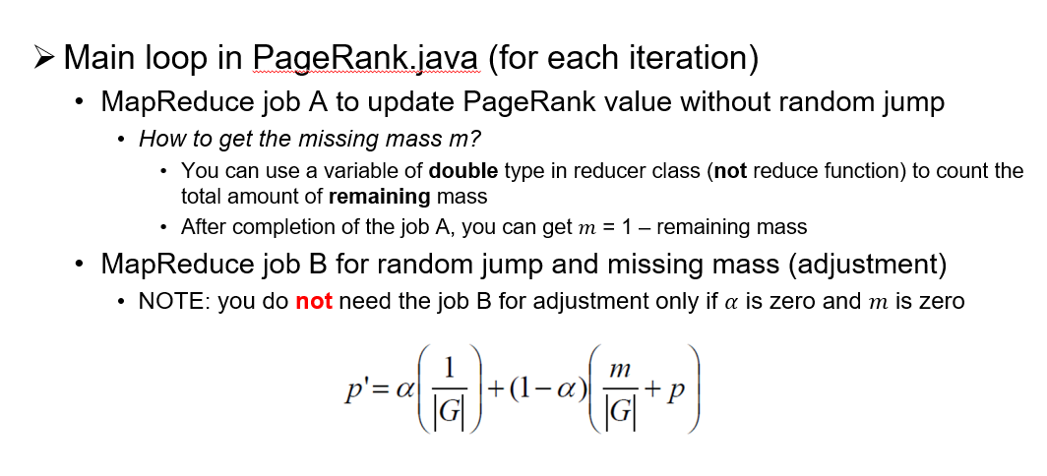

**PageRank Convergence:** Iterate until PageRank values don’t change. Iterate until PageRank rankings don’t change. Fixed number of iterations. In fact, pages are dynamic, and PageRank algorithm need to be fun from time to time.

**Key-Value Stores (lec 6) (Big Table)**

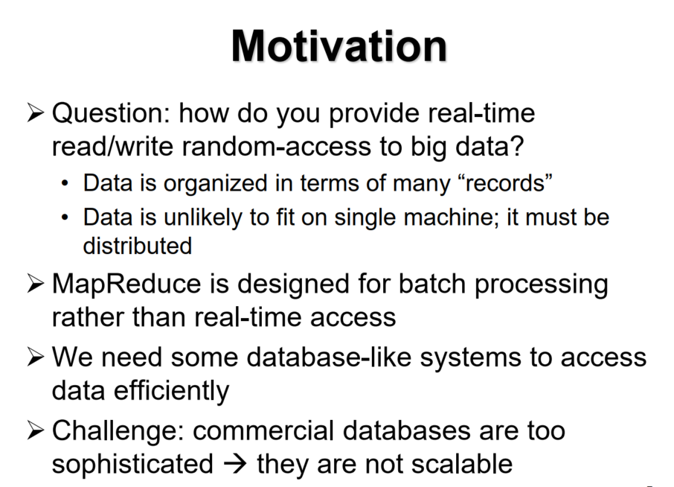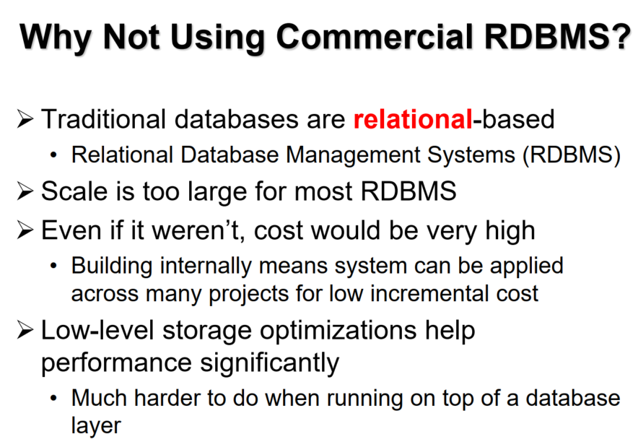

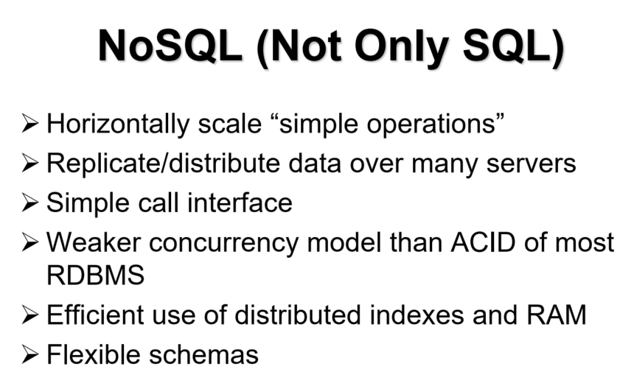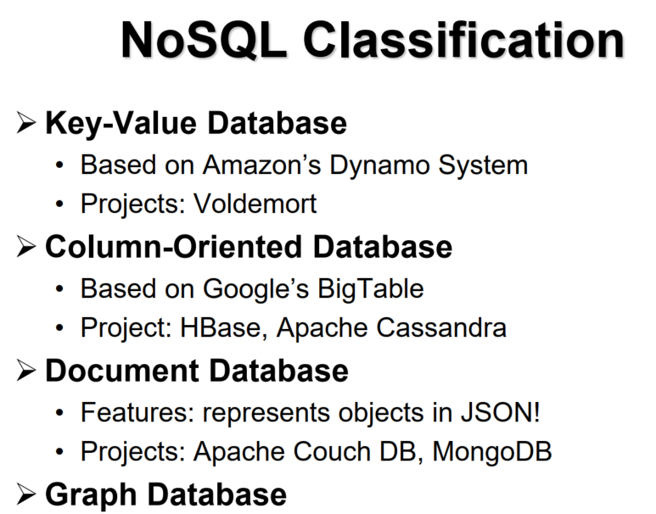

**Objectives of BigTable:** need to support very high read/write rates. Efficient scans over all or interesting subsets of data. Joins large one-to-one and one-to-many datasets. Also often want to examine data changes over time. **Goal of BigTable:** Distributed multi-level map, fault-tolerant, persistent and scalable for thousands of servers, terabytes of in-memory data, petabyte of disk-based data, millions of reads/writes per second. Also self-managing, servers can be added / removed dynamically, adjust to load imbalance. (**HBase is distributed, column oriented (scalability))**

**Reverse URL:** help to identity for URL under the domain name.

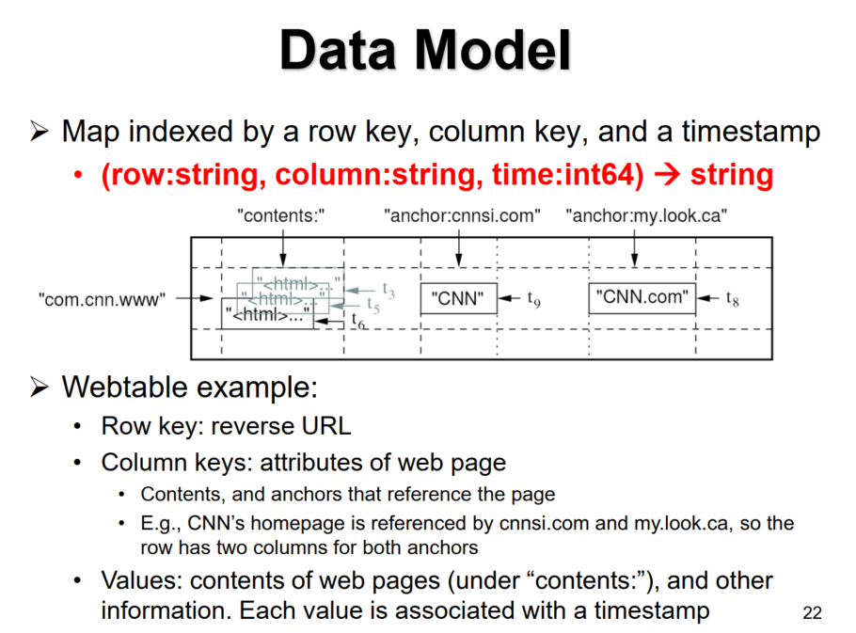 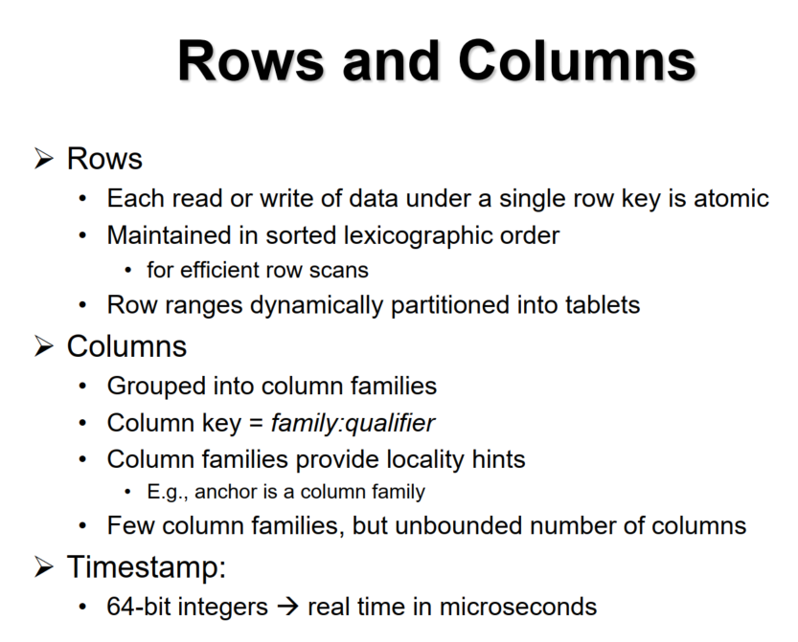

**Building Blocks: GFS** raw storage for storing log and data files. **Chubby** a distributed lock manager, keeps replicas consistent in presence of failures.

**SSTable** a file format for storing BigTable data.

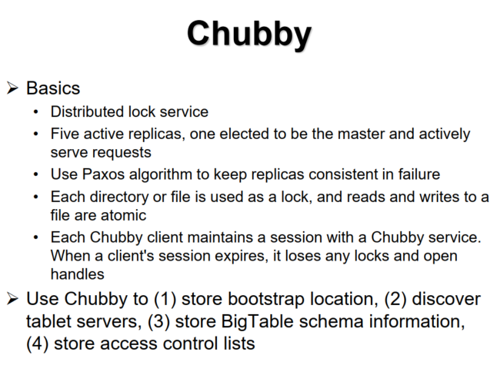 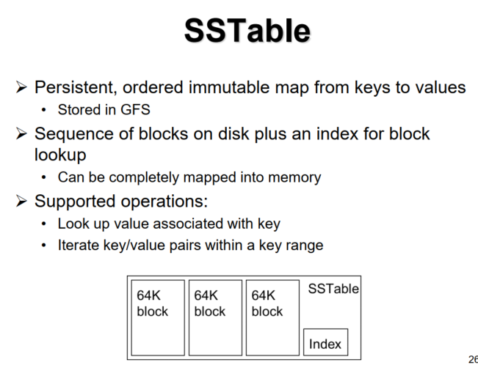

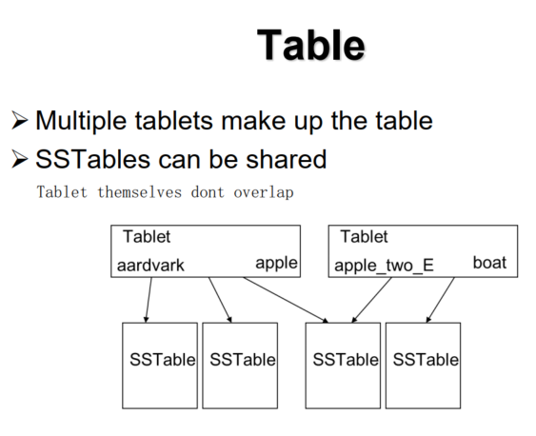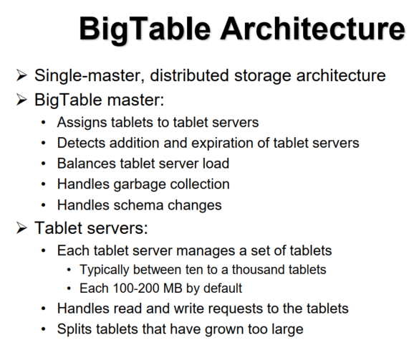

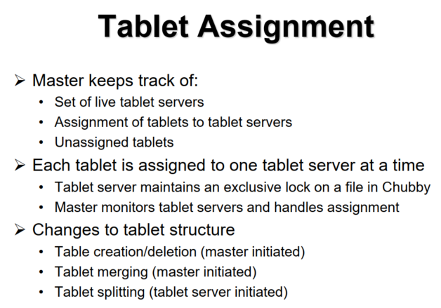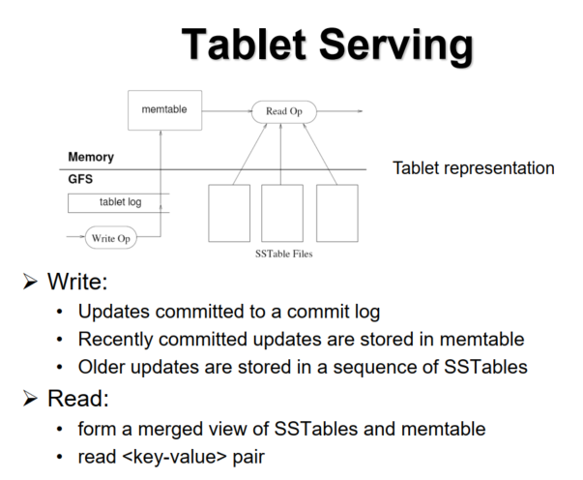

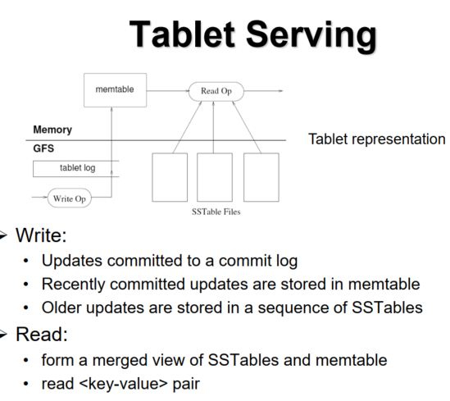 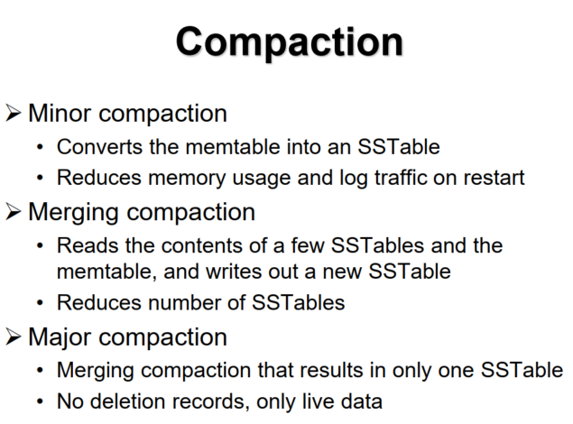

**Key-value Store (Dynamo)**

**CAP Theorem**

**C: consistency,** by which a shared and replicated data item appears as a single, up-to-date copy

**A: availability,** by which updates will always be eventually executed.

**P: partition tolerance,** by which partitioning of nodes can be tolerated. Any networked system providing shared data can provide only two of the three props.

**C & P:** e.g., distributed database systems (Big Table)

**Consistency?** When a user writes data, the same piece of data is written to all storage servers.

**Partition Tolerance?** All storage nodes are guaranteed to have the same piece of data, even though part of system is disconnected.

**Availability?** Cannot hold because when failure happens, can’t proceed the update because the update is blocked by the failed node.

**A & P:** e.g., DNS system

**Availability?** Yes, every node in system will always be available no matter the <IP-name> pairs is valid or not.

**Partition Tolerance?** By design, every user has its own DNS server on its own network, so network partitioning is not a problem.

**Consistency?** Cannot hold, Ip address and hostname will changing according to time, the mapping will need 1-2 hours reflect on all DNS server, so there is a time that the mapping is invalid, not consistent on all DNS.

**C & A: e.g., single node database**

**Consistency?** Must be hold

**Availability?** Must be hold

**Partition tolerance?** Cannot hold because if the node fails, no other copy and no-fault tolerance.

**CA:** Traditional relational databases Postgre SQL, MySQL

**CP:** BigTable-like systems HBase, MongoDB, Redis, MemcacheDB

**AP:** Dynamo-like systems Voldemort, Fiak, Cassandra, CouchDB

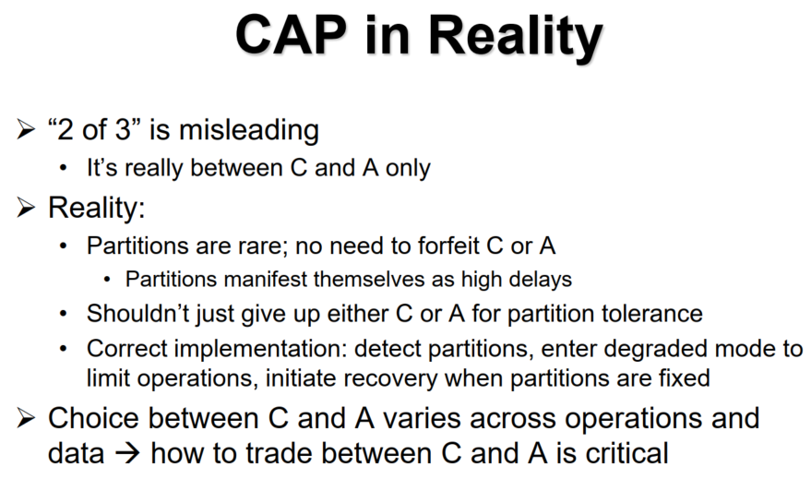

**Amazon Dynamo:** dynamo is designed as a highly available, key-value storage system. Assumptions and Requirements: Simple read/ write operations, uniquely identified by keys. Objects tend to be small (< 1MB)

**ACID** gives poor availability. Use **weaker consistency** for higher availability.

No security issues, under single authority. Application can configure dynamo for resired latency & throughput, balancing performace, cost, availability and durability guarantees. Dynamo aims to be always writable, for high availability, avoid rejecting updates , and let the app to resolve conflicts. **Design Principles of Dynamo:** 1. Incremental scalability – able to grow by adding a storage host at a time. 2. Symmetry - all node providing storage ( violated by BigTable, HDFS ). 3. Decentrailziation – No central coordinates ( violated by BigTable ). 4. Heterogenity – workload partitioning should be proportional to capabilities of servers ( difficult to achieve without centralized coordinator )

**Compared to BigTable:** Dynamo targets apps that only need key/value access with a primary focus on high availability. 1. Key-value store vs. column store ( column families and columns within them) 2. BigTable is distributed DB built on GFS while Dynamo is distributed hash table.

3. Updates in dynamo are not rejected even during network partitions or server failures.

**Consistency vs Availability:** strong consistency and high availability cannot be achieved simultaneously with high performance.

**Replication of Objects**: **Pro** High availability and high read performance as these copies will balance the read workload. **Con** need to update all of them to maintain consistency.

Dynamo enforces **eventual consistency**. Progates updates to all replicas eventually , trade weak consistency for availability and performance. In this model, reads may return old data that is yet updated, application need to resolve conflicts, fall back on “last write” wins or return multiple version of shopping carts to users.-

**Dynamo’s storage:** Key space of nodes **= {0, 1, …, n – 1}**

Set of objects **= {$o_{1},o_{2}, ..., o_{k}$}.** Create a hash function **h(x)** such that **h(x)** map an element in **{$o_{1},o_{2}, ..., o_{k}$}** to number i. Object x will be stored in node i. h(x) should be deterministic, efficient and evently distributed among all nodes. In Dynamo, a key is hashed with MD5 to create a 128-bit identifier, combined with modulo operation. h(x) = MD5(x) mod n.

**Cons: If we add / delete a new node, n will be n + 1 / n – 1. We need to rearrange all the objects and there will be traffic problem.**

**17 mod 5 = 2 and 17 mod 4 = 1. Move the object to node 2 to node 1.**

**17 mod 5 = 2 and 17 mod 6 = 5. Move the object from node 2 to node 5**

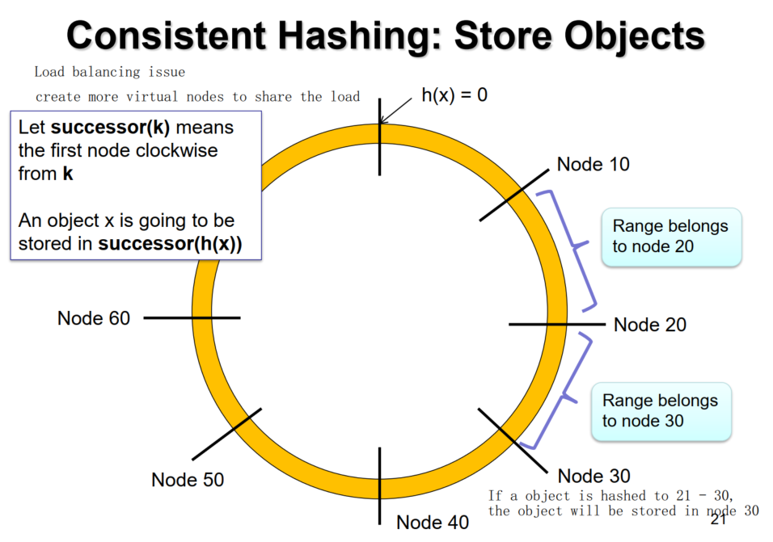

**I**f a new node is added, only data of the successor node is affected**. For** example, if node 26 is added, data from node 30 is migrated to node 26. Routing table need to be updated. If a node is deleted, the data in node deleted will need to migrate to successor node.

**Consistent Hashing: Replication**

Stores and object to N storage servers. 1st server is the one closest to h(x) in the clockwise direction. Then N-1 move servers, who are clockwise successors of successor(h(x)), will store a redundant copy of object x.

e.g., h(x) = 15, N = 3, node 20 stores first copy, node 30,40 store other 2.

**Client-Side Consistency**

**Strong Consistency:** after the update reports a finished update, all subsequent access returns the updated value.

**Eventual Consistency:** After the update reports a finished update, the system may report the old value. Nevertheless, the system will eventually report the updated value.

**Server-Side Consistency** (Below are Configurable Parameters)

**N** =the number of nodes that store replicas of the data. **W** = the number of replicas that need to **acknowledge the receipt of updat**e. **R** = the number of replicas that are **contacted when a data object is accessed.**

**If W + R > N, then it is strong consistency.**

If N = 3, W = 2, and R = 2, a write completes only when any two replica writes are confirmed. A read returns the values of any two replicas, 1 must be up-to-date copy, then resolve conflict by data version.

N = 2, W = 2, R = 1 (BigTable)

**W + R <= N** is eventual consistency.If N = 3, W = 2, R = 1 (W + R = N), the read has a chance to read the old value. But the performance is high.

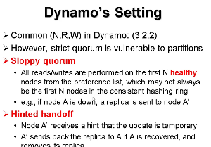**Tradeoff** here is add some complexity to the node, let the node know that the update might be temporary, and Dynamo used to use that.

**Deduplication (lec 8):** an approach that eliminates redundant data on storage. Instead of storing multiple copies of data of the same content, only one copy is stored.

**Deduplication vs. Compression**

**Compressio**n reduces the number of stored bits compared to original data. Transforming data into new representation with higher entropy, typically work on a single file (or a single batch of file), byte-level, fine-grained compression.

**Deduplication** detects identical data / similarities between data chunks, work across files, coarse-grained compression.

In practice, compression has to be performed after deduplication.

**Fingerprinting:** using the content to generate cryptographic hash with MD5, SHA-256 etc. If hash(a) == hash(b) then file a and b are the same. But there is small chance for **hash collision**. (Different files generate the same hash) **Fixed size (boundary shift problem)**

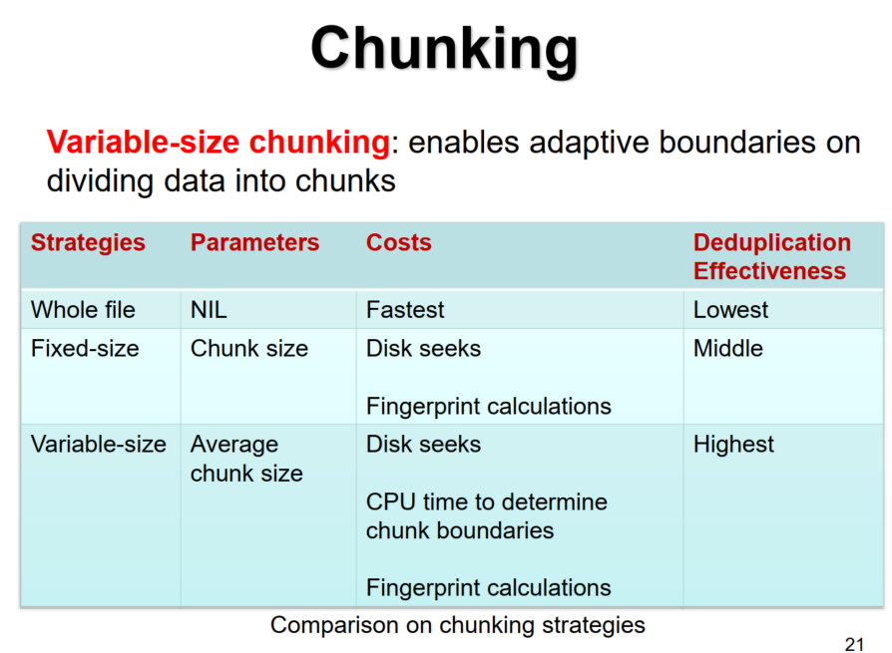

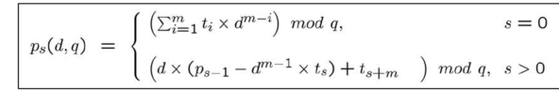

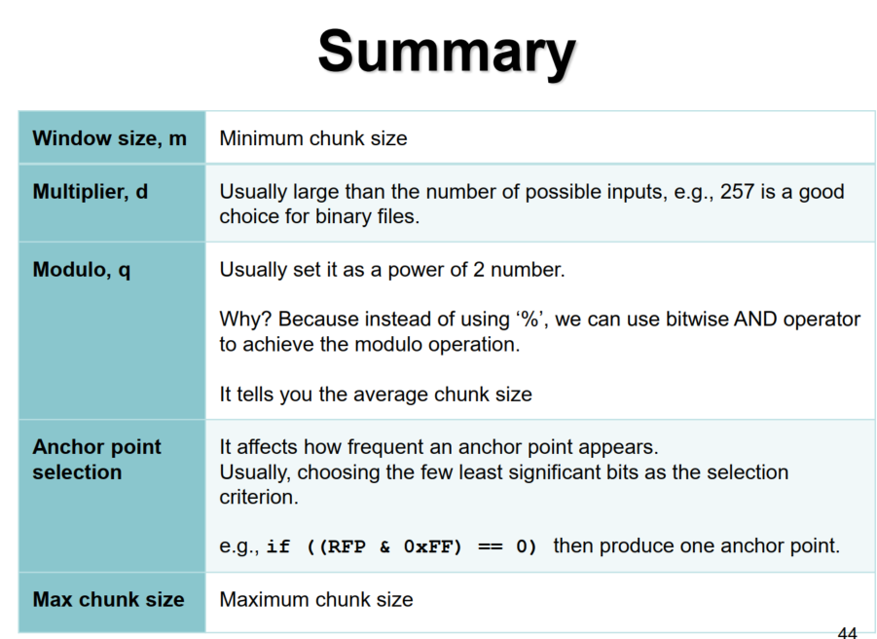

**P.S. q** cant be too large and too small. **d** should be larger than the largest value of the set of alphabets to avoid hash collision. Critical RFP = 0 for fast computation. Zero chunks --> many chunks with min chunk size  
Chunks with only one --> max chunk size

**Inline vs. Offline Dedup**

**Inline deduplication:** immediately checks each data chunk for prior appearances, duplicate chunks are never stored.

**Offline (out-of-order) deduplication** first stores all data on secondary storage, searches for duplicates in idle periods, no immediate impact on performance, idle periods have to be bigh enough to perform deduplication. (writing and removing redundant data, wasting bandwidth)

**Index Structure in RAM:** Memory overhead

**Index Structure on Disk:** updating each data chunk and its index keeps disk arm moving, hurts performance.

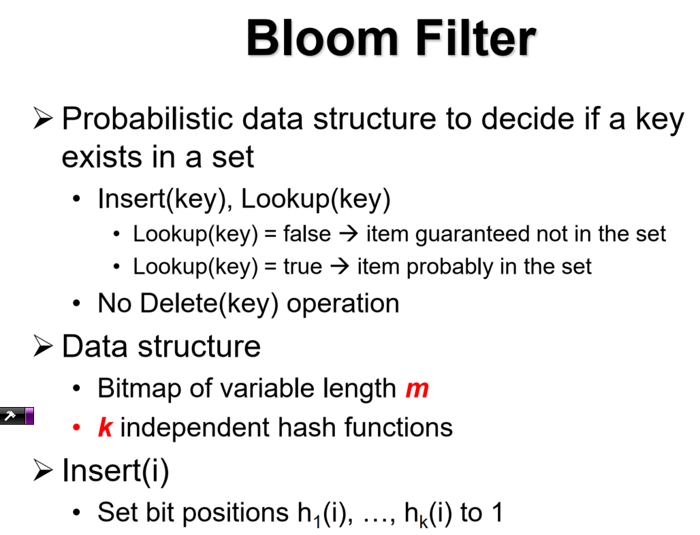

**P.S. as m increases, the prob. For false positive decreases.**

**Bloom Filter in Deduplication**

**Two-level index structure:**

**Bloom filter in memory:** check if a fingerprint has been (probably) inserted. **Full chunk index mappings on disk:** Check If a fingerprint has been actually inserted. (Possible to have false positive case)

**Bloom filter for fingerprints:** Lookup(fp) = false $→$ No chunk index lookup needed. Lookup(fp) = true $→$ Lookup on disk required.

**Sparse indexing: Chunk Locality** is tendency for chunks in backup data streams to recoccur together. Introduce a new level of granularity, called segments, each segment consists of a number of chunks, the segment size in order of 10MB.Each segment is characterized by hooks, which are fingerprints of chosen chunks. Sample hashes whose first n bits are zeroes (Sampling rate = 1/2^n). All hooks are part of in-memory index. Metadata of a segment, including fingerprints of all chunks is stored in a manifest file.Given an incoming segment, check the hooks in the sparse index, and identify already stored segments that are the most similar. (**Champion**).

Then load manifests of selected champions into memory and deduplicate chunks. Sparse indexing is near – exact deduplication, has storage overhead but saves a lot of memory. **(One back up source)**

**Extreme Binning: File similarity** means two backup streams share files with similar chunks. First, we choose a representative fingerprint of a file which should be a minimal fingerprint. Because by Broder’s theorem, if two files are similar, the minimal fingerprint from two file have high chance to be the same. Then store all metadata of one file to one bin, including fingerprints of all chunks. Then bin is stored in secondary storage (similar to manifest in Sparse Indexing). The Primary in-memory index stores the representative fingerprints, SHA-1 value of complete file, and the pointer to the bin. To write files, each file is chunked, and all fingerprints are calculated. If representative fingerprint is not in the primary index, store all chunks, create a new bin and store all metadata.

Else if the SHA-1 value for complete file isn’t identical to the primary index’s one, that means the file are similar, then load the corresponding bin from secondary storage, store all chunks not in the bin, update the metadata in the bin and store bin. **P.S. Do not update the whole file hash.**

**Summary:** the above techniques target for backups – write-intensive but read-rare.

**Fragmentation**

**Inline deduplication:** check if every new chunk can be deduplicate with any existing chunk on write path. If chunk exists, reference it, otherwise, add to last write position. However, data is no longer sequentially stored. Many I/O seeks when restoring the file.

**Naïve Solutions: Offline Deduplication** to remove existing duplicate chunks at the background. However, there is extra I/Os. (writingand removing redundant chunks). **Chunk rearrangement** but chunks are shared across disk, expensive I/O.

**Containers:** Chunks are grouped into containers, typically of size 4MB or 8MB. Overhead of reading the whole container is small but the I/O seek overhead is reduced.

**Capping:** Break a data stream into fixed size segment (20MB), determine which chunks are already stored in which containers. Choose up to T containers, ranked by how many chunks they contain, breaking ties to favor the most recent containers. Any duplicate chunks, if not referring to the T containers, are treated as new chunks.

**Forward Assembly Area:** Prefetch next M bytes into in-memory buffer and assemble the M bytes in sequence and return it to client.

**Performance:** Capping 2-6X 8% dedup loss, Forward assembly area 2-4X.

**Convergent Encryption:** C = $E_{H(P)}(P)$, P = $D_{H(P)}(C)$

But its not safe if attackers know the range of P, he can launch the offline brute-force dictionary attack as the key is derived from the chunk. Solution: Use a key that is deterministically derived from some one-way function but looks random to attackers. (Use Server-Aided instead)

**Server-Aided Encryption:** Client send a fingerprint **f** to a key manager. And key manager generates key by **OWF(f,s)** where **s** is a random seen known to the key manager only. **Extension – Rate-limiting key generation requests** to avoid attackers to ask for so many keys. **Blinded key generation**: key manager can generate the key without knowing f.

**Dropbox Security:** Use Amazon S3, data deduplication with SHA-256, files split in 4MB chunks, using AES-256

**Side-Channel Attacks:** each client checks if the same file has been uploaded. If not, upload it, else stop. This saves unnecessary upload bandwidth. Then attackers can upload a file and observes whether deduplication occurs. IF there is deduplication, the attacker knows the file copy exists. **Generalized to infer file contents**:performing a brute force attack by trying all possible contents of a file.

**Hash Value Manipulation Attack**: Dropbox clients for Linux and Mac OS X link to NCrypto to generate SHA-256 hashes, but the client do not verify integrity of NCrypto. Hackers can modifies the open source code of NCrypto and inject their fake hash value. If the fake hash doesn’t exist on Dropbox server, server will request the file from client. If the fake hash exists, Server doesn’t ask for the file. Instead, the server links the corresponding file / chunk to the hacker’s Dropbox account. Hacker can access to file / chunk which belongs to others.

**Stolen Host ID Attack:** Host ID is a 128-bit key generated during the setup of the Dropbox Client on a computer or smartphone. It will be linked to owner’s Dropbox account. No further authentication is needed.

IF the hostID is stolen, attacker can access all the files.

**Direct Download Attack:** Transmission protocol is built upon HTTPS, you can POST with SHA-256 and a valid host ID. Any valid host ID can download the file, Dropbox wont check if the chunk is linked to the account. Same effect as hash manipulation attack but less stealthy.

**Direct Upload Attack:** uploading without linking, if a hostID is known, attacker can push data to other users.

**Solutions:** Dropbox reacted in April 2011, host ID is not encrypted on disk, no more client-side data deduplication. But Server side deduplication implies more upload bandwidth.

**Facebook Photo Storage (lec 9)**

**Design Goals: High throughput and latency – minimize disk I/Os ,**

**Fault-tolerant – replicate photos in geographically distinct locations,**

**Cost effective – cost per terabyte of usage must be kept low,**

**Simple – Straightforward to implement and maintain**

**Typical Design: CDN – content delivery network** is a network of nodes that cache contents, which serves a large-scale cache. **Pros** world-wide scale deployment, fast response time**. Cons authority** will control expiry of content. CDN fits well typical website because people access up-to-date data most of the time and old contents are seldom read.

Facebook Limitation: Facebook (or social networking sites) has a different access pattern from web. Old contents are frequently visited. Long tail behavior – Requests from the long tail ( or very old content) account of a significant amount of time. NFS based Design -> expensive I/O and metadata overhead. **Haystack:** develop customized file system with lightweight metadata operations (Haystack directory and Haystack store)

Offload CDN with a customized cache (Haystack cache).

**User Operations**: when user visits a page, web server forwards the request to the Directory. The Haystack Directory construct the URL for each photo – **http://<CDN>/<Cache>/<Machine id>/<Logical volume, photo>.** The CDN looks up the photo internally, if the lookup fails, the CDN strips the <CDN> part from the URL and contacts the Cache. If Cache lookup fails, the Cache strips the <Cache> part from the URL and contacts the Store. **Haystack Directory:** 1. Provides a mapping from logical volumes. 2. Determines whether a photo request should be handled by the CDN or by the Haystack Cache. 3. Identifies logical volumes that are read-only. Serves like the name node in **HDFS.**

**Haystack Cache:** Distributed hash table, uses photo’s id to locate cached data. Receives HTTP requests from CDNS and browsers. If photo is in Cache, return the photo. If not, fetches photo from the Store and return the photo. Add a photo to Cache If the request comes directly from browser not CDN, and the photo is fetched from a write-enabled store machine. Because Haystack Cache assume CDN will cache the photo, if Haystack also cache the photo, there will be duplicated caching. Write-enabled means the machine is not full and these photos are newly added which may be accessed soon.

**Haystack Store: Haystack store file** asuperblockfile accompanied by many needles, log-structured format – append only

Haystack index file provides minimal metadata required to locate a particular needle in the store. Same order as store file, a subset of store file, but without photo data. This is for disaster recovery, less than 1% of store file. Each store machine manages multiple physical volumes. Can access a photo quickly using the id of the corresponding logical volume and the file offset of the photo. **Haystack Stores – Read:** Each stores machines maintains an in-memory index, if both CDN and Haystack cache miss the photo, look up the index **0 I/O**, then the offset in the store file is found. Assume that the store file is always opened, seek and read. Seek takes **1 I/O** and the succeeding read doesn’t take any because the seek op has position the disk head. Totally, **1 I/O** is needed. **Haystack Store – Write:** a multi-write operation to three replicas. Append 4 images (1 replica) to the store file, seek to the end of file and sequentially write, 1 I/O. Then append 4 images to the haystack index file. Seek and then sequentially write. Update the in-memory index. Total **6 I/O for 3 replicas**.

**Haystack Store – Delete:** A multi delete operation to three replicas. First, remove files in the in-memory index, because delete in disk will cause fragmentation. Then mark the 4 images of file deleted, 4 seek and write, also 4 I/O for marking delete in index file. Together 24 I/O for 3 replicas.

**Garbage Collection:** Create a copy of the store file and skip deleted photos while copying. 25% of photos get deleted in a given year.

Haystack Key contribution: 1. **Reduced I/O**, 10TB/node → 10GB of metadata. ~10 bytes per image, ~40 bytes per photo. 2. **Simplified metadata** – No directory structures / file names, only 64 bit ID, results in easy lookups. 3. **Single photo serving and storage layer**, reduce I/O overhead. **BLOBs Storage:** Binary Large Objects, are immutable binary data, created once, read many times, never modified, may be deleted.

Examples: videos, photos, documents, source code etc.

Temperature Zones: Hot – BLOBs receive many requests, warm – BLOBs receive few requests, Cold – BLOBs almost receive no requests.

P.S. More than 80% objects are warm of all types. Remaining are hot.

Applying replication to warm content proves fault tolerance but high storage overhead. **Triple replication of data files + (10+2)-RAID-6.** RAID-6 on 12 disks of each replica. Redundancy factor = no. of total disks / no. of disks used for data. Replication factor = 12 / 10 * 3 = 3.6X. Min. no. of disks failures cause data loss = 9 (all replicas loss) Haystack use **f4 fault tolerance** for warm objects. **Erasure Coding:** Divide file into k data blocks, encode data blocks to additional n-k parity blocks. Encoding is done via Galois field arithmetic. Distribute n data/ parity block to n nodes. Fault tolerance – any k out of n blocks can recover file data.

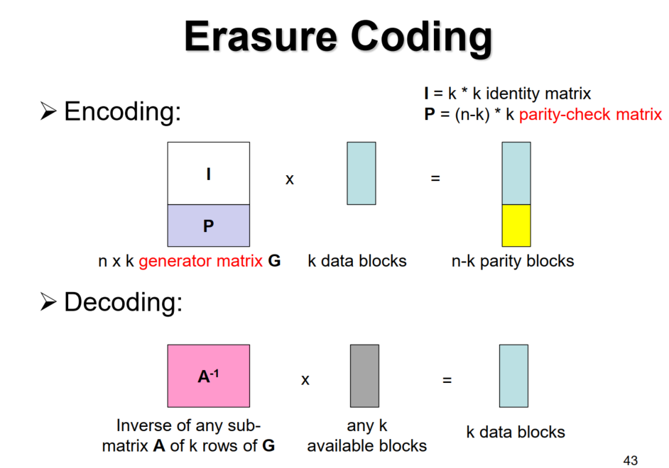 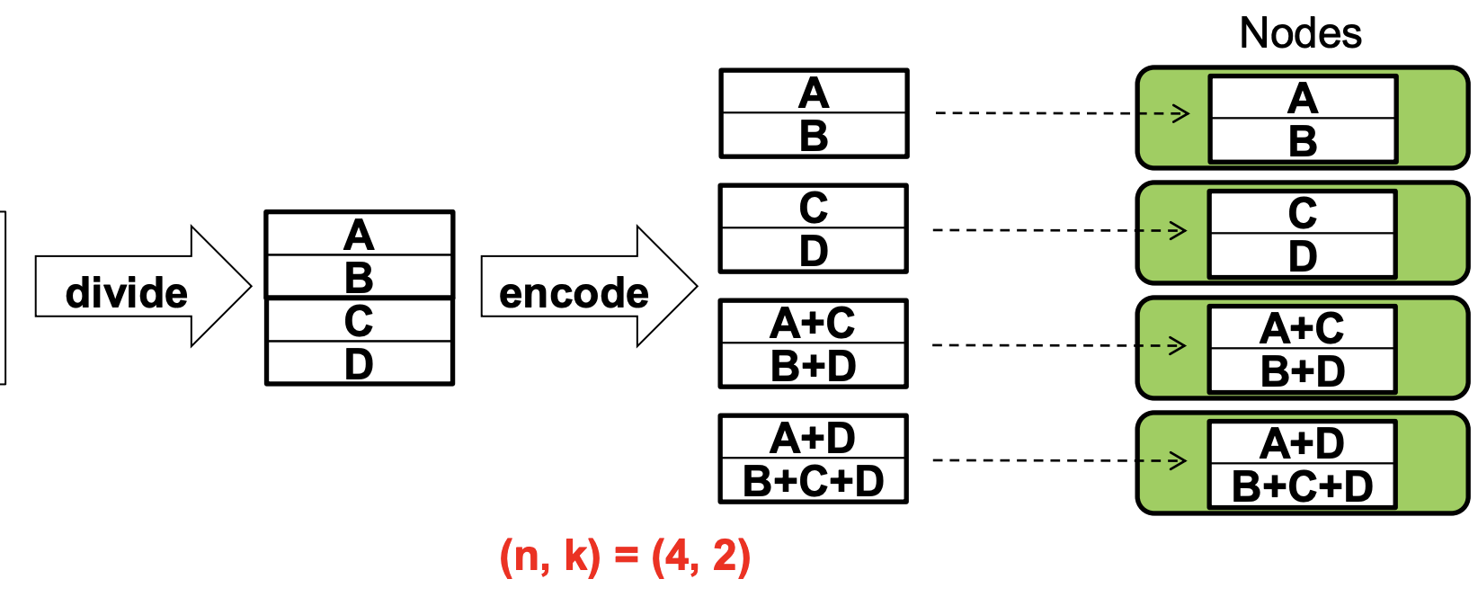

**Reed-Solomon codes** is the most popular. Support any n and k (provider n > k). Minimum storage redundancy n/k to provide the fault tolerance against any n – k failures. F4: (n,k) = (14, 10). **Pros** reduce storage space, high fault tolerance. Cons In general, k blocks needed to recover a lost block → expensive repair (read amplification)

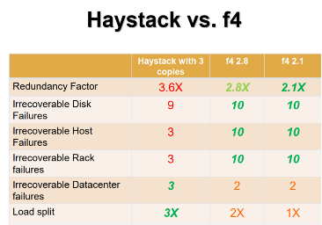**Erasure coding in f4**: Block size = 1 GB. Each block has multiple BLOBs and large block size reduces metadata management. Distribute each RS (14,10) stripe across 14 racks. **Double Replication:** Replicating a stripe in two cells at two diff. data centers. Redundancy factor = 1.4 * 2 = 2.8x

**Geo-distributed XOR coding:** Add an XOR parity to two stripes. Redundancy factor = 1.4 * 1.5 = 2.1x.

**P.S. 1 block in 1 disk / 1 host for f4.**

**Atomic no need to worry about the difficulty of partial success**

**Zookeeper**

**Zookeeper helps HBase** with crash recovery. Zookeeper is a highly available, high-performance coordination service. Zookeeper is a file API without partial reads/writes, no renames, ordered updates and strong persistence guarantees, condition updates, watches for data changes, ephemeral nodes, generated file names.

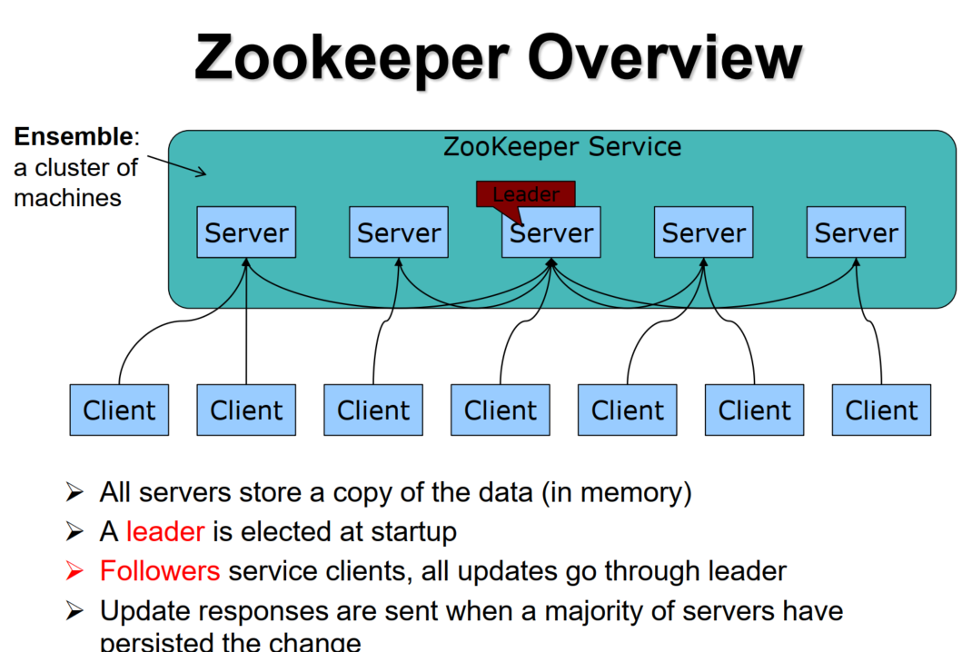

ZooKeeper uses a protocol called Zab that runs in two phases:

**Leader election** – selecta a member called the leader and the other machines be followers. This phase is finished once a majority (quorum) of followers agree on the election result will call this successful.

**Atomic broadcast** – all write requests are forwarded to the leader, which broadcasts the update to the followers. And this update will be committed if a majority agree. Consensus is designed to be atomic so a change either succeeds or fails. **Data Model –** A client can create a znode, read and write data to **znode** Inside ZooKeeper. Znodes are organized in a directory-like structure. Call the intermediate nodes groups. Call the leaf nodes group members. Think of Zookeeper as a file system because the hierarchical namespace and able to store data. But the Znodes are not designed for general data storage (size of data cannot be too large, otherwise very difficult to maintain consensus across severs). Instead, znodes map to abstractions of the client application, e.g., **metadata**. Znodes can store data with max. 1MB. Zookeeper doesn’t use handles to access znodes, use absolute paths directly and save overhead of open () or close (), simplify the design and states. Data access is also atomic, reading the data at a znode will never receive only some of the data. Either the data will be delivered in its entirely or the read will fail.

**Persistent (regular) znodes** – Clients manipulate persistent znodes by creating and deleting them explicitly. Usually represent groups or intermediate nodes. **Ephemeral znodes** – Client create such znodes and znodes will deleted in 3 cases. Clients delete them explicitly, or the system remove them when the session creates them terminates. Or the sessions have an associated timeout, Zookeeper considers a client faulty if it does not receive anything from its session for more than the timeout. Usually represent the existence of a client, i.e., leaf node. Watches allow clients to get notifications when a znode changes. A client may wait on the creation of a znode, If the znode is created, the watch is triggered. Watchers are triggered only once. Clients need to reregister the watch to receive multiple notifications. (Avoid notification overhead)

PERSISTENT & EPHEMERAL – The naming of znodes has to be specific and unique. If a client with a duplicated pathname is joining a group, it will be rejected. PERSISTENT_SEQUENTIAL & EPHEMERAL_SEQUENTIAL – The naming of such znodes contains a client-defined prefix and the monotonic increasing, numerical postfix. Example, creating a sequential znode /zoo/fubar, the resulting name will be /zoo/fubar001. Another client create /zoo/fubar, the creation will not be rejected, and the resulting name will be /zoo/fubar002.  
Herd Effect

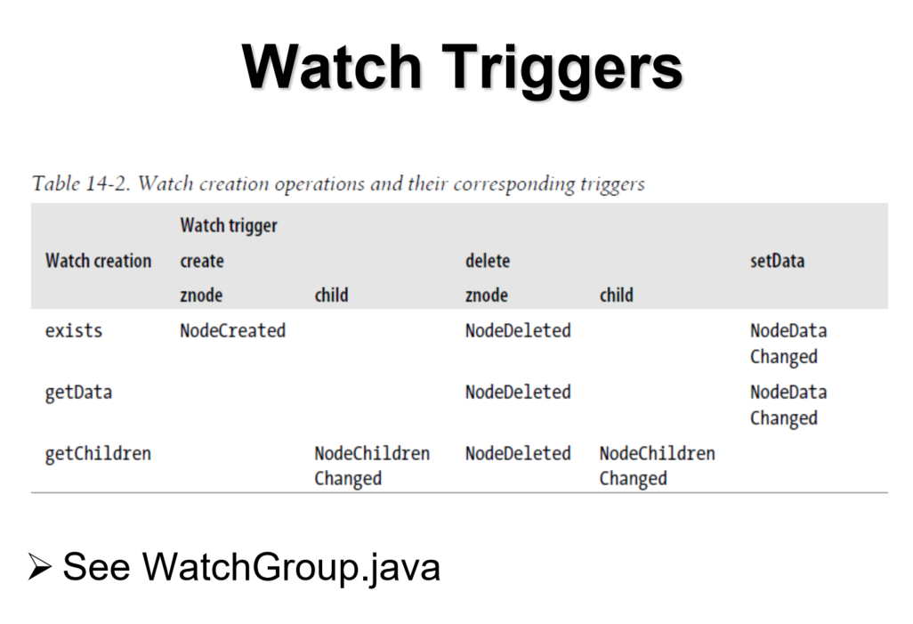 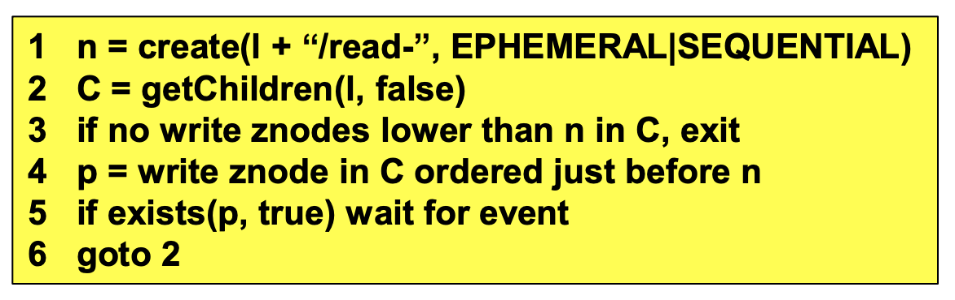

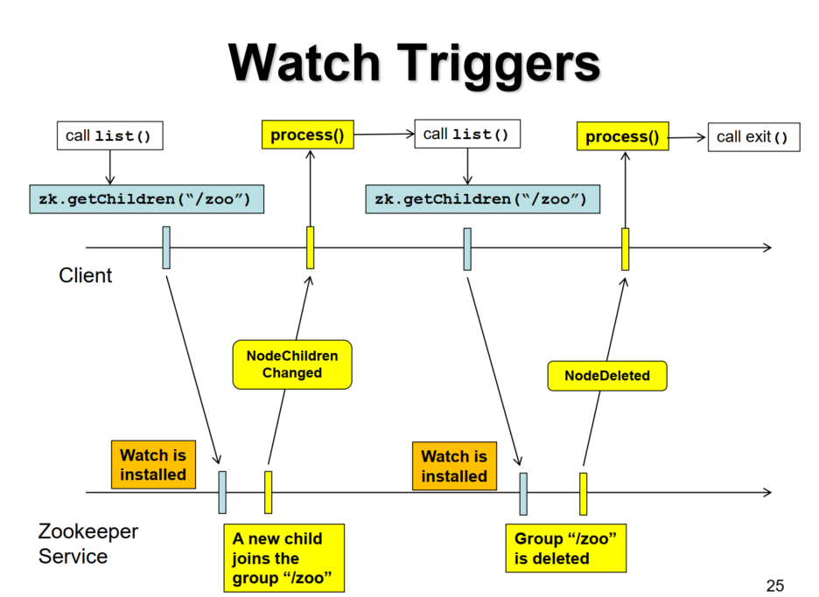

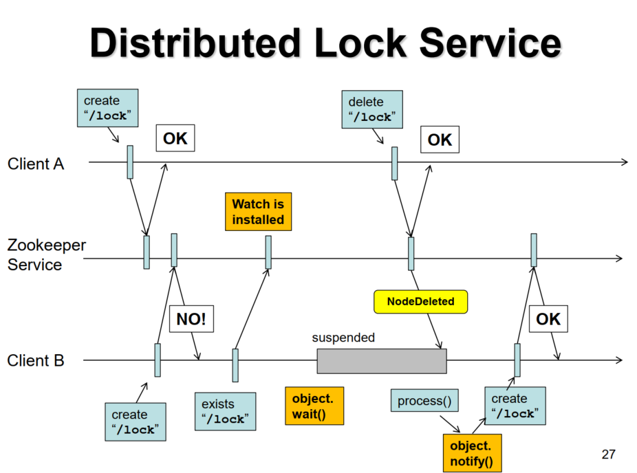

**Herd effect:** hundreds of clients waiting for the lock and many notifications are sent but only one of them can get the lock. Notifications are wasted and there is overhead. Avoid herd effect using a set of “EPHEMERAL_SEQUENTIAL” clients. **(No Herd for the read lock)**

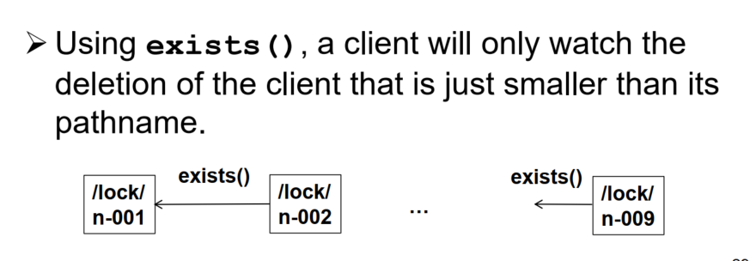

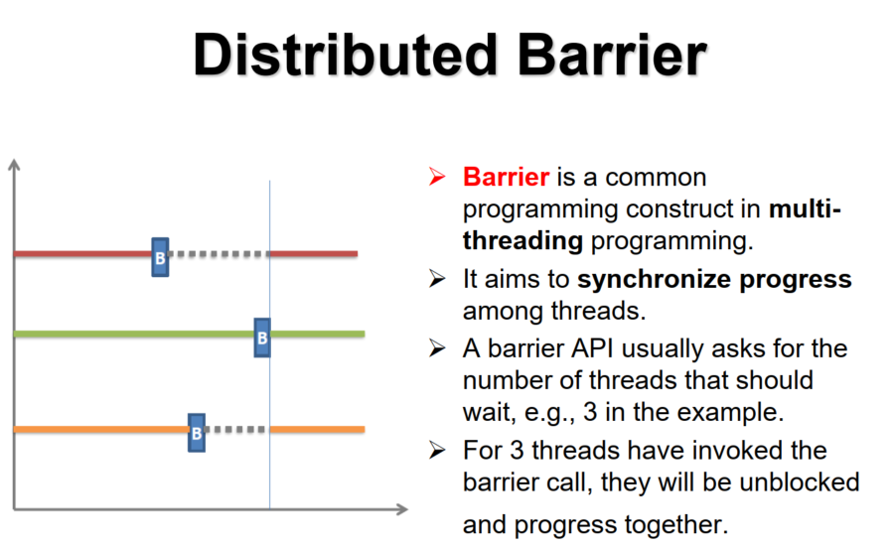

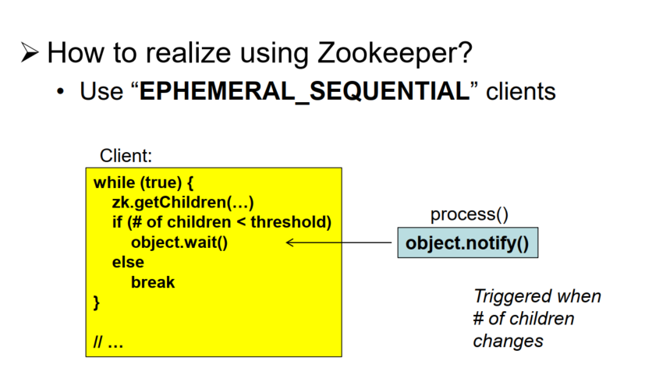

**Distributed Producer-Consumer queue (FIFO)**

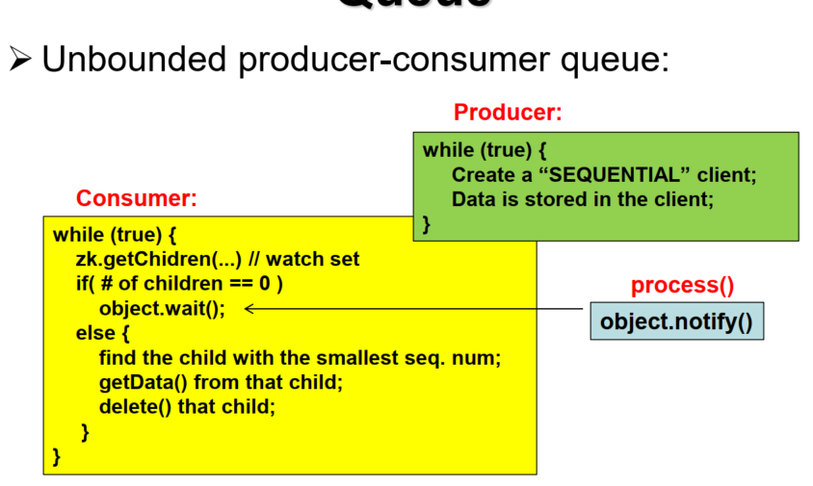

**Tail Tolerance**

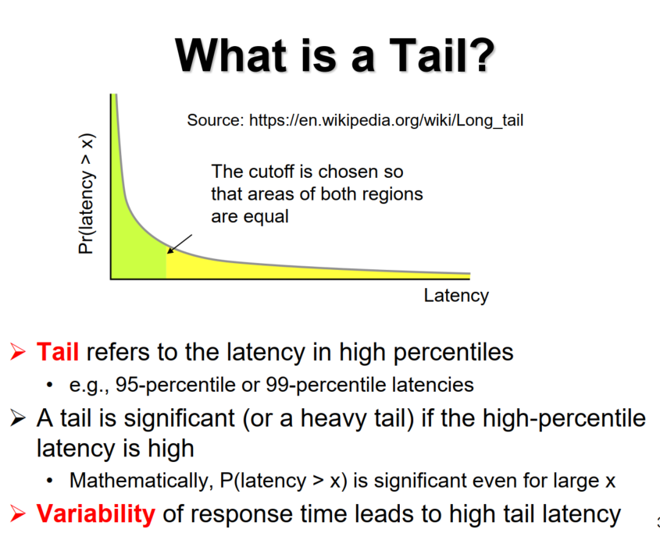

Tails are bad because it dominates the overall performance, may violate the server level agreements (SLA may state 99.9% of requests are completed within 300 milliseconds), and bad user experience.

Solutions: Treat slow servers as hard failures. Replace slow servers with new ones but there could be many false positives.

Variability exists because of **resource sharing** (CPUs / disks within machines / Switches or shared file systems), **background jobs** (Daemons, maintenance, garbage collection), **queueing** and **energy management** (Power limits of modern CPUs / Power saving modes).

**Variability Amplified at Scale:** Parallelization is often used to reduce latency, but also amplifies variability. For example, a request is broken into sub-operations that are issued to multiple servers in parallel. These sub-ops must all complete. Let Pr(latency > 1s) = 0.01. Sub-ops of a request issued to 100 servers. $Pr(request > 1s) = 1 - {( 1 - 0.01 )}^{100} = 0.63$. If a request is issued to one server, the $Pr(request < 1s) = 0.99$. **Reducing variability:** Differentiating server classes and higher-level queueing, reducing head-of-line blocking by breaking a long-running request into smaller slices and allow them to interleave with others. Also manage background activities and synchronized disruption. On the other hand, we can cache data that resides in slow nodes. But it is useful only when the entire working set can reside in a cache.

**Within Request Short-Term Adaptations:** Replication of data items across servers to provide both fault tolerance and tail tolerance. **Hedged requests** – send a request to the primary server and send the same request to a diff. server after some delay. Cancel any outstanding request if the response is received. **Tied requests** – Enqueue copies of a request in multiple servers simultaneously, allow servers to communicate updates on the status of these copies to each other (send a cancellation message when the request is processed). P.S. In Google’s implementation of tied requests, medium latency is reduced by 16% and 99.9-percentile latency is reduced by 40%. **Cross-Request Long-Term Adaptations: Micro-partitions –** generate many more partitions than servers, perform load balancing at the (more fine-grained) partition level. Allow servers to slightly increase or decrease the partitions they served, provide more flexibility for load balancing. **Selective replication** – detector predict certain items (or micro-partitions) that are likely to cause load imbalance and create more replicas of them. Spread the load of these hot items like MapReduce. **Latency-f probations –** if a server is detected to respond slowly, put it on probation. Exclude requests to the slow servers. Issue shadow requests to the slow servers and collect statistics from them, bring the servers back to normal if they are ready.

**Special Cases: Take “good enough” response** – Once a sufficient fraction of all servers responded, the user accepts the slightly incomplete result for better end-to-end latency. **Canary requests –** Rather than initially send a request to thousands of servers, send it first to one or twoservers. The remaining servers are only queried if there is a successful response from the canary in a reasonable period of time.

P.S. The above techniques are reactive or proactive.

**Tails In Storage**

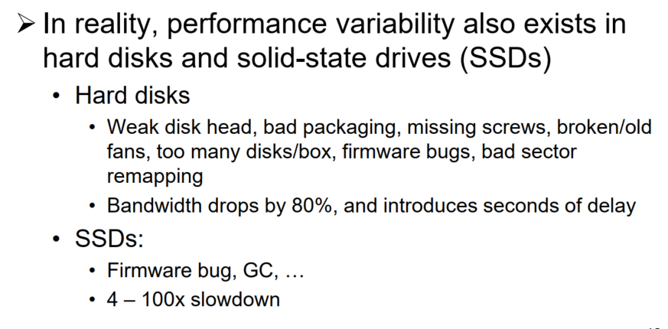

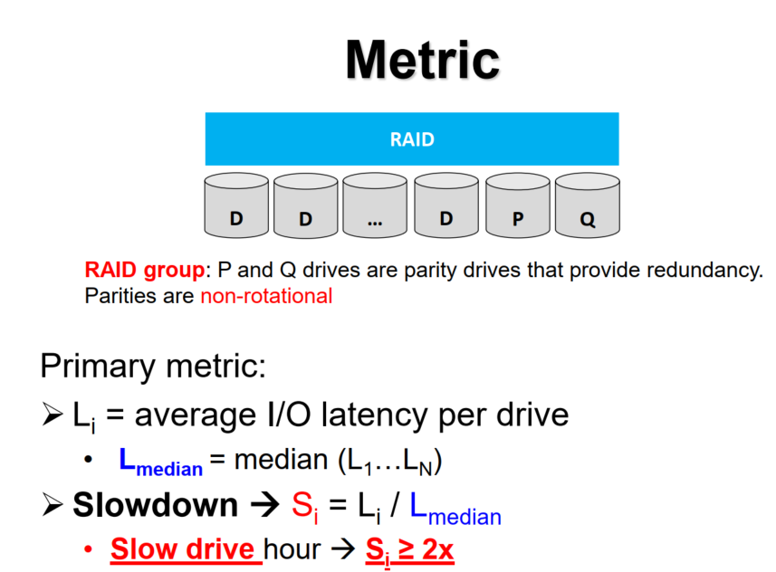

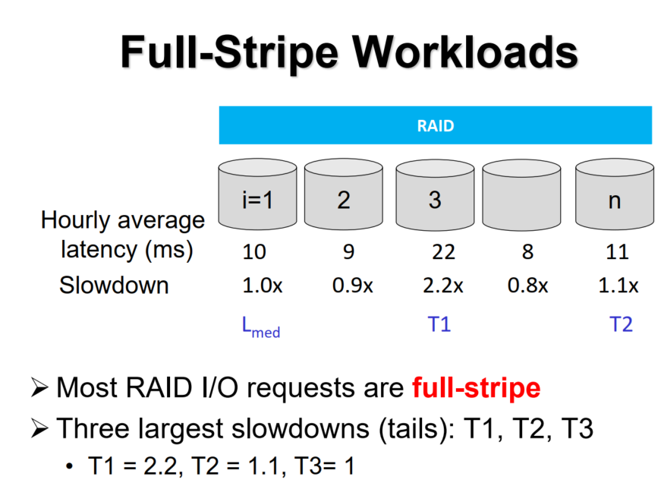

**Observations:** Storage performance instability is common. Slowdown can persist over several hours. 25% of disks have seen $≥$ 2x slowdown. 29% of SSDs have seen $≥$ 2x slowdown.

**Conclusion:** Slowdown is independent of I/O rate and size imbalance. Slowdowns are not accompanied with any explicit drive events. Older disks tend to have more slowdowns, but no age correlation for SSDs. Single-level-cell (SLC) SSDs slightly outperform multi-level-cell (MLC) SSDs in terms of performance stability. Slowdown depends on SSD vendors. No correlation with time of day. And Slow drive replacement rate is low. Unplug – 4-8% (within 24 hours after a slowdown). Replug – 89 – 100% of unplugged drives are replugged.

**How to be tail-tolerant: Reactive – i**f a drive didn’t return data after a timeout, perform an extra read to parity drives**. Proactive –** perform extra reads to parity drives concurrently with original I/Os**. Adaptive – I**f the reactive policy is triggered repeatedly on the same drive, use the proactive policy. **Trade-offs: Reactive –** slow response time. **Proactive:** extra read traffic. Writes is not a problem as we can always cache the data and flush to the drive after a period of time.